CONSENT ITEM F
January 27, 2025
OLDHAM COUNTY BOARD OF EDUCATION
CONCERN
Consider Shortened School Day request for OCS students.
DISCUSSION
The following students have requested a Shortened School Day. Details for each student follow this enclosure for your review.
STUDENT | SCHOOL
A.D. | OCHS
B.M | Harmony
M.L. | Kenwood
R.L. | Goshen
RECOMMENDATION
Post-approve the shortened school day request for these students.

On a motion by _______________, seconded by _______________, the Board post approved the Shortened School Day requests as submitted. ( )

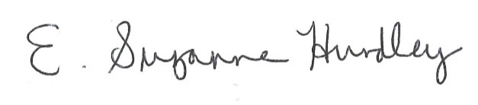
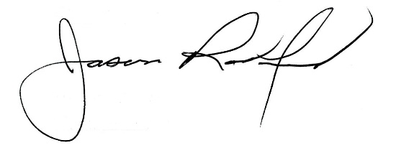

Suzanne Hundley, Board Chair Jason Radford, Superintendent/Secretary

