ACTION ITEM A
January 27, 2025
OLDHAM COUNTY BOARD OF EDUCATION
CONCERN
Consider approval of FY24 Audit Report
DISCUSSION
LBMC PC (formerly Strothman & Company) will present and discuss the FY24 audit report. A pdf of the report is attached for your review.
RECOMMENDATION
Approve the FY24 Audit Report as submitted.

On a motion by _______________, seconded by _______________, the Board approved the FY24 Audit Report as submitted. ( - )

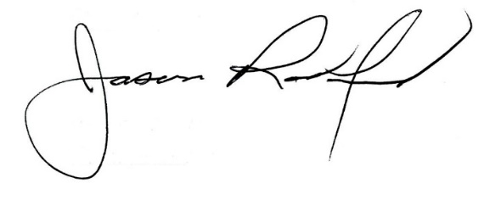
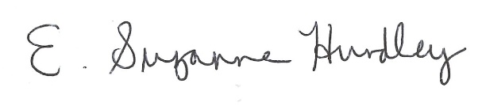

Suzanne Hundley, Board Chair Dr. Jason Radford, Superintendent/Secretary

