ACTION ITEM E
January 27, 2025
OLDHAM COUNTY BOARD OF EDUCATION
CONCERN
Consider approval of FY24 Audited AFR and Balance Sheet
DISCUSSION
The AFR and Balance Sheet are initially submitted to the Kentucky Department of Education (KDE) by the district in July following the close of the fiscal year on June 30. Upon completion of the district financial audit, the district posts all audit adjustments in order to ensure district financial records agree with the audited financial statements.
The AFR and Balance Sheet are completed and have been submitted to KDE subject to Board approval. A pdf of the reports is attached for your review.
RECOMMENDATION
Approve the FY24 Audited AFR and Balance Sheet as submitted.

On a motion by _______________, seconded by _______________, the Board approved the FY24 Audited AFR and Balance Sheet as submitted. ()

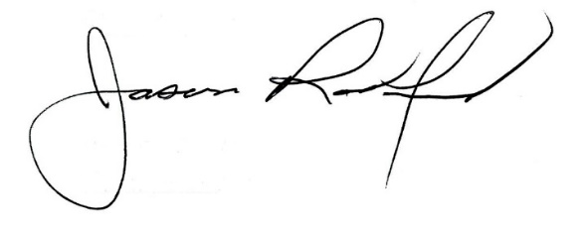
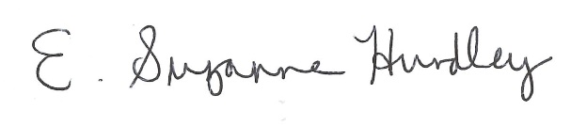

Suzanne Hundley, Board Chair Dr. Jason Radford, Superintendent/Secretary

