ACTION ITEM B
January 27, 2025
OLDHAM COUNTY BOARD OF EDUCATION
CONCERN
Consider Approval of the proposed FY26 Board Meeting Schedule.
DISCUSSION
The proposed FY26 Regular Board Meeting Schedule as follows:
Regular Board Meeting Dates Arvin Education Center – 4:45 pm
OCS Board Meeting Dates | Enclosures Due by Noon | Student Showcase
Monday, July 28, 2025 | Monday, July 21, 2025 | N/A (summer)
Monday, August 25, 2025 | Monday, August 18, 2025 | N/A (summer)
Monday, September 22, 2025 | Monday, September 15, 2025 | TBD
Monday, October 13, 2025 | Monday, October 6, 2025 | TBD
Monday, November 17, 2025 | Monday, November 10, 2025 | TBD
Monday, December 15, 2025 | Monday, December 8, 2025 | TBD
Monday, January 26, 2026 | Monday, January 19, 2026 | TBD
Monday, February 23, 2026 | Monday, February 16, 2026 | TBD
Monday, March 23, 2026 | Monday, March 16, 2026 | TBD
Monday, April 27, 2026 | Monday, April 20, 2026 | TBD
Monday, May 18, 2026 | Monday, May11, 2026 | TBD
Monday, June 22, 2026 | Monday, June 15, 2026 | N/A (summer)

FY26 Annual SBDM Presentation to the Board Arvin Education Center – 4:45 pm
SBDM BOARD MEETING DATE | SCHOOL SCHEDULE
SBDM BOARD MEETING DATE | 4:45/5:15 | 5:15/5:45 | 5:45-6:15 -Dinner Break | 6:15/6:45 | 6:45/7:15 | 7:15/7:45
Thursday October 2, 2025 | ARTS/CAPAA | EOMS | 5:45-6:15 -Dinner Break | SOMS | OCMS | NOMS
**Board Enclosure Packet is due on September 25, 2025 |  |  | 5:45-6:15 -Dinner Break
Thursday, November 6, 2025 | ARVIN | NOHS | 5:45-6:15 -Dinner Break | BAHS | SOHS | OCHS
**Board Enclosure Packet is due on October 30,.2025 |  |  | 5:45-6:15 -Dinner Break
Thursday, January 15, 2026 | CE | LA | 5:45-6:15 -Dinner Break | GO | BU | CR
**Board Enclosure Packet is due on January 8.2026 |  |  | 5:45-6:15 -Dinner Break
Thursday, February 12, 2026 | HA | LG | 5:45-6:15 -Dinner Break | KW | Preschool | CA
**Board Enclosure Packet is due on February 5,.2026 |  |  | 5:45-6:15 -Dinner Break

RECOMMENDATION
Approve the FY26 Board Meeting Schedule as presented.

On a motion by _______________, seconded by _______________, the Board approved the FY26 Board Meeting Schedule as presented ( - )
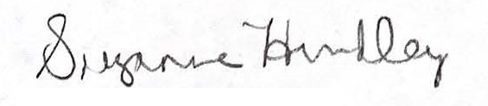
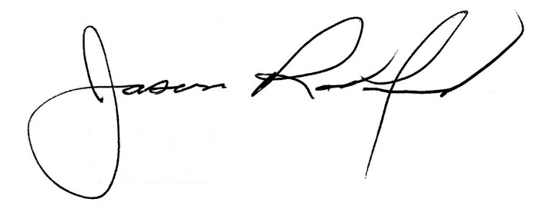

Suzanne Hundley, Board Chair Jason Radford, Superintendent/Secretary

