Strategic Prevention Framework
I³: Inspired, Individualized, Inclusive
December 2024 - January 2025
Goal: To reduce the onset & progression of substance misuse & its related problems in Bellevue, KY, by supporting the development & delivery of community substance misuse prevention & mental health promotion services.
Objective 1: | By 9/29/2027, reduce the 30-day use of alcohol among tenth-grade students by 2% each year as measured by annual KIP survey data.
Objective 2: | By 9/29/2027, reduce regular (30-day) vaping use among tenth-grade students by 2% each year as measured by annual KIP survey data.
Objective 3: | By 9/29/2027, reduce regular (30-day) cigarette smoking among tenth-grade students by 2% each year as measured by annual KIP data.
Objective 4: | By 9/29/2027, tenth-grade students reporting serious psychological distress, according to the K6 KIP data, will decrease by 4% each year.
Objective 5: | By 9/29/2027, expand collaboration with community prevention partners, demonstrated by support from community prevention partners at least 2x each year in the project’s family prevention education opportunities, documented by photographic evidence & meeting notes.

ASSESSMENT
Accomplishments | Description | Align
Assessment of schools’ capacity: | I³ staff, in collaboration with GES & BMHS school leadership to complete the SEB Winter Screener | 1-5
Specification of baseline data: | SEB screeners will be given to all K-5 students (teacher-rated) and 6-12 (teacher-rated and youth-rated).  The data will be used within the MTSS framework to proactively detect students who need support beyond Tier 1 instruction & support. *  - GES completed teacher-rated on 12/18/24 (194 students)  - BMHS incomplete; scheduled to complete teacher-rated on 1/3/25  *Data utilized in MTSS meetings at GES, BMHS SEB data utilization unknown | 1-4
Monitoring schools needs assessment activities: | Internal Referrals for mental health services. *  1 internal referral for services (GES only)  1 internal referral accepted  0 internal referrals in progress  5 internal referrals for prevention services  1 internal referral assessment completed for prevention services  BMHS MTSS Tracker  GES MTSS Tracker  *Specific BMHS mental health referral data and internal referral assessments unknown | 1-4
Monitoring schools needs assessment activities: | External Referrals for mental health & prevention services. *  0 student/family external referral  0 student/family Care Solace referrals  0 staff member's Care Solace referrals  *Specific BMHS external referral data unknown | 1-4
Monitoring schools needs assessment activities: | Grant staff collect & monitor data on all grant lead initiatives. This includes, but is not limited to:  - Outreach & Engagement Data  - Participation Data  - Outcome Data  - Financial Data  - Progress Monitoring | 1-5
Use of needs assessment data: | Grant staff continues to redirect efforts to target the community with infrastructure development initiatives. | 5
CAPACITY
Accomplishments | Description | Align
Professional Development: | SPF Grant Staff:  - PTAC Navigating Prevention Systems Changes at the State-Level  - UK CTAC TIPE Learning Collaborative Learning Call  - Stronger Together: Leveraging School-Community Partnerships for Prevention Success  - Defining, Analyzing, and Selecting Tier 2 Supports  - Prevention Science in Action: Supporting Families & Schools in Raising Healthy Kids  - The SAMHSA Grant Application Process  GES Mental Health Professional:  - Play Therapy for Children, Adolescents and Adults  - Going from Reactive to Proactive Getting Tier 3 Right  - Am I doing Tier 2 & 3 Right? 5 Indicators to Implement Tier 3 with Confidence  - The Body Keeps the Score Trauma Training (In progress) | 5
Building internal coalitions: | Grant staff participated in the following monthly coalition/committee meetings:  - GES PBIS Tier 2/3 Meeting  - GES Student Care Team Meeting  - GES Student Care Team - Ancillary Meeting  - 5K Initiative Planning Committee  - Rae of Sunshine - SMILE Club Meeting  - Finance meetings | 5
Building external coalitions: | Grant staff participated in the following monthly coalition/committee meetings:  - North Key  - NKY ASAP  - SBMH Grant Committee Meeting  - TISS Grant Committee Meeting  - NKISP Steering Committee Meeting  - Campbell County Drug-Free Alliance General Meeting  - River Cities Drug-Free Coalition Meeting  - Team Kentucky – Prevention & Promotion Branch | 5
Building external partnerships: | Grant staff meet with the following community agencies:  - North Key  - City of Bellevue  - Starbucks  - Kroger  - Trader Joe  - Perfetti Van Melle | 5
Community Conversations: | - Bullitt County Meeting to discuss Vape Disposal  - NKY Health Department – to discuss TGFD  - CCDFA to discuss video campaign & Prom initiative  - 5k  - Vets  - St. Elizabeth  - Sun Behavioral  - Ryan Salzman – City Council  - City of Bellevue
Other infrastructure development: | - Review & update the webpage with resources weekly. MH&Prevention Webpage  - Resource mapping review & update support for students, staff, & families. BISD Resource Map | 5
PLANNING
Accomplishments | Description | Align
Articulation of a vision for prevention activities: | Grant staff will work with school leadership to discuss the following:  - Implementation of video campaign.  - Planned for 01/30 (kickoff)  - MTSS tiered level of support & SEB Screener Capacity & Decision Rules | 1-5
Articulation of a vision for prevention activities: | Grant staff are working toward planning the following:  District  - Lockbox Video Campaign with CCDFA and SMILE Club  GES  - Too Good for Drugs Curriculum with NKY Health Department  BMHS  - Prevention Campaign (BHS)  JANUARY  - 01/03 – BMHS Screener scheduled  - 01/06 – Compliment Bulletin Board  - 01/07 – SMILE Club – prep for leading empathy lesson during ENGAGE (canceled)  - 01/08 - SMILE Club leading ENGAGE sessions (canceled)  - 01/09 - SMILE Club  - 01/17 - Spill the Tea  - 01/17 - I3 Newsletter #3  - 01/21 - I3 Advisory Meeting  - 01/22 - Self-esteem Groups @ GES  - 01/22 - 5K Planning  - 01/24 - National Compliment Day  - 01/28 - NKCES Trauma Make & Take  - 01/29 - SMILE Club Concession Stand Fundraisers  - 01/30 - Video Campaign Kickoff  FEBRUARY  - National Thank You Month  - 02/03 - SMILE Club Concession Stand Fundraisers  - 02/07 - Pop the Stigma Initiative partnered with Perfetti Van Melle  - 02/10 - SMILE Club Concession Stand Fundraisers  - 02/17 - Random Acts of Kindness Day  - 02/18 – Dinner Table Project #3  - 02/19 - SMILE Club Concession Stand Fundraisers  - 02/21 – Spill the Tea Initiative  WINTER  - Newsletter  - Dinner Table Project  - Weekly Rae of Sunshine - SMILE Club Meetings  - Prevention Day (Feb 2025)  - Pop the Stigma  - #SELday  SPRING  - Newsletter  - Dinner Table Project  - Weekly Rae of Sunshine - SMILE Club Meetings  - Mental Health Roundtables  - Mental Health Month  - Mental Health Day of Action  - 5K Initiative | 1-4
Identification of the district-level priorities: | Mental Health & Prevention Services Handbook—I³ team continues to create an evidence-based policy and procedural handbook for BISD’s mental health and prevention services.  - Outlines the screening process  - Details referral process  - Includes information about MTSS | 1-5
Identification/coordination/allocation of resources: | Prevention Specialist trained in Catch My Breath. | 1-3
Identification/coordination/allocation of resources: | Trauma-Informed Grant – The I³ team is working with NKCES to evaluate the strengths and weaknesses of BISD’s Trauma Plan. The team will review recommendations based on the trauma-informed walkthrough that took place on 12/4. | 4
IMPLEMENTATION
Accomplishments | Description | Align
Specific community-level interventions being implemented: | Grant staff implemented the following:  DECEMBER  - 12/04 - Trauma Walk Through (GES & BMHS)  - 12/04 – GES Trauma/SEL Presentation during ERD  - Bellevue Newspaper article  - 12/06 - Trauma Book Study  - 12/11 - BMHS Character Strong Audit (rescheduled)  - 12/12 - Weekly Rae of Sunshine - SMILE Club Meetings  - 12/13 - UK #iCANendthetrend Presentations  - 12/16-12/20 – SEB Screener Window #2  - 12/17 – #iCANendthetrend post-survey #1  - 12/17 – Dinner Table Project #2  - 12/18 – GES Screener completed  - 12/18 – Emotional First Aid for Teacher presented by SMILE Club (Rescheduled)  - 12/20 – Abbreviated Newsletter  - 12/20 – Spill the Tea  - 12/20 – Sober Fun for the Holidays and abbreviated SPF Newsletter, including sober fun & support for the holidays  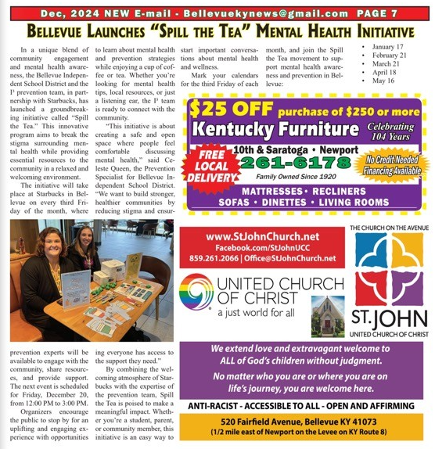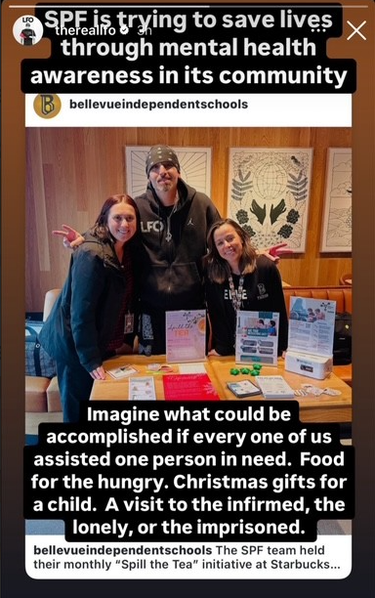  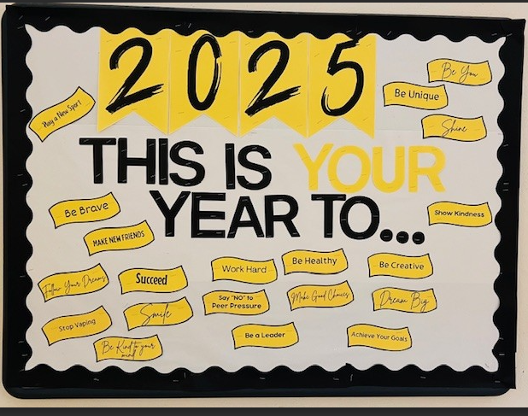
Implemented policies within organizations to facilitate interventions | Grant staff works with the following grants to create procedures for the BISD mental health & prevention team in response to students' & families' mental health & prevention needs. These align with best practices.  - Trauma-Informed Grant  - Grant staff continues to work with TISS Grant to revise BISD’s trauma-informed plan & create action steps to ensure the implementation of best practices.  - Grant staff continues to work with SBMH Grant to review & revise BISD’s Mental Health plan & create action steps to ensure the implementation of best practices.  - School-Based Mental Health Grant  - Grant staff continues to work with SBMH Grant to review & revise BISD’s Mental Health plan & create action steps to ensure the implementation of best practices.  - Prevention  - Grant staff continues to review & revise BISD’s Prevention plan, creating action steps to ensure the implementation of best practices.  - Created district tobacco/nicotine-free procedure in response to HB-142; the procedure was added to the Code of Conduct and middle/high school behavior matrix. | 4
Specific community-level interventions being implemented: | SBMH Breakdown of time and/or student reached/seen:  - Direct: 1,160 minutes = 19.3 hours  - Total Sessions: 29  - Extra Sessions: 227 minutes = 3.8 hours  - Meetings: 570 minutes = 9.5 hours  - Indirect: 630 minutes = 10.5 hours  SBMH GES Caseload Numbers:  - Active cases: 17  - Tier 2 performance: 0  - Referrals: 1 | 4
Specific community-level interventions being implemented: | Prevention Breakdown of time and/or student reached/seen:  - Direct sessions: 500 minutes; 8.3 hours  - Groups: 0 minutes = 0 hours  - Tier 2 performance: 0 minutes = 0 hours  - Indirect: 6 students; 440 minutes; 7.3 hours  Prevention Caseload Numbers:  - Active cases: 3  - Referrals: 2  - Pending: 2  - Tier 2 performance: 0 | 1-4
Developed systems for distributing resources: | 0 lockbox has been provided to families of students  22 lockboxes have been distributed in total  Receiving Deterra bags from NKY ASAP to distribute | 1-3
EVALUATION
Accomplishments | Description | Align
Monitor & evaluate all activities: | Evaluating SEB data to support our developing MTSS. | 4
Monitor & evaluate all activities: | SPF Grant Data  - Outcome data collected on the number of event impressions and post-survey information  - Data submitted to SPARS  Total Served to Date = 3,361  Total Reached to Date = 33,929  Holiday Newsletter = 43 served  GES Health Class for Self-esteem = 81 served, 1386 reached  Lockboxes = 22 served  SMILE Club Meetings = 12 served  Dinner Table Project #2 = 163 served (75 students)  Total to Date:  Dinner Table Project = 457 served, 3167 reached  Spill the Tea = 29 served, 4728 reached | 4
Monitor & evaluate all activities: | Dinner Table Project #2 Post-Survey Data collected and reviewed; used to modify elements of the project to better suit students and families. | 4
Monitor & evaluate all activities: | #iCANendthetrend post-survey #1 collected; will review once results are received from the program. | 1-5
Grant Reporting: | - 12/31 - SPF eRa Commons Annual Performance Review - Submitted  - 12/31 - SPF eRa Commons Carryover - Submitted  - 01/31 - SPF Continuation Report – Submitted  - 3/30 - SPF SPARS Quarter 1&2 Report – Due

SUSTAINABILITY
Planning for sustaining the infrastructure: | Continue developing & improving the district's MTSS system & mental health support. SEL teams deliver substance abuse prevention curriculum to students.

