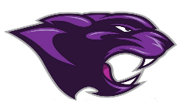

Board Meeting
December 2024

December 2024 Board Meeting
Jr/Sr. High School Principal

Clubs
- Clubs (National Honor Society, FCA,)

Band Concert
- Held on the 8th

KSA Awards Day
- Students will be awarded certificates for Proficient and Distinguished
- 21 Parking Signs were handed out to our top students
- 5 returning signs

Rewards Day Trip
- Students will be going Movies and Lunch

College & Career Ready
- 31 seniors are College and Career Ready

PLC’s
- Have been meeting regularly

SBDM
- The CSIP has been completed and up to date and approved by SBDM

