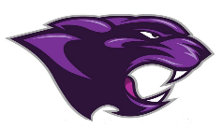

Board Meeting
November 2024

November 2024 Board Meeting
Jr/Sr. High School Principal

Cross Country
- Pep Rally for State

Junior Beta, Beta and National Honor Society Induction
- Held on the 6th

Clubs
- FCA has had several speakers
- Rotary Interact Club

Veterans Day
- Held on the 11th

Several visitors this month during FLEX
- University of the Cumberlands visit
- Marines
- We Lead meeting
- Sophomores visited MCC and Caldwell Regional Tech Center
- ASVAB Testing on the 22nd
- Black Light Dance
- Murray State visit

