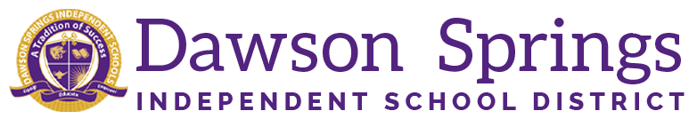

Dawson Springs Elementary School
Where the teachers and students give 100% every day and failure is not an option.
Panthers Prowling to Proficiency!

October 2024 Board Meeting
Elementary Principal Report
Jennifer Ward

- Academic Progress
  - Midterm grade reports went home last week.
  - iReady Fall screener has been completed for both reading and math
    - Reading - 73% of students tested where they needed to be for the beginning of the year
    - Math - 74% of students tested where they needed to be for the beginning of the year
    - First grade had the highest percentage of students at placement level on the fall iReady screener for reading and math
- PLC Conversations for the Month:
  - KSA individual student data has been disaggregated and our “bubble kids” have been identified. These are the students who are right on the edge of either moving up or down a level on testing results.
    - Teachers have started conducting individual student conferences to set goals for this year.
  - CSIP Goals for the 24/25 school year will begin to be modified for the current school year with staff members.
  - Reading intervention plans for students under the 25th percentile on reading assessment results from iReady will be created in IC and monitored monthly for progress towards exiting the plan.
  - Our book study on Focus Elevating the Essentials to Radically Improve Student Learning BY Mike Schmoker is going great!
    - Lots of deep conversations about classroom instructional delivery and getting back to the basics. The overall summary for the book can be summed up as follows:
      - What is truly “essential” for schools? The evidence points hard to three fundamental elements: reasonably coherent curriculum (what we teach); soundly structured lessons (how we teach); and large amounts of purposeful reading and writing in every discipline (authentic literacy - integral to both what and how we teach).
      - We have learned about the need for simplicity and focusing on these three key components of effective instruction.
      - We are currently studying in depth the “what we teach” portion of our book and discussing how its not about “fads” and programs, but about a clear, “viable” curriculum for every course. Aligned, essential standards.
- Upcoming Events:
  - November 21 is our next SBDM meeting at 3:30 PM.
  - November 25 is our next Friday Morning Assembly with November Student of the Month winners

