THIS IS A DECISION PAPER

TO: HARDIN COUNTY BOARD OF EDUCATION

FROM: Teresa Morgan, Superintendent

DATE: OCTOBER 17, 2024

SUBJECT: APPROVE REESOR PROPERTY LETTER TO KDE

ISSUE: KDE REQUIRES BOARDS TO COMMUNICATE THEIR PROPERTY SEARCH EFFORTS IN A LETTER

FACTS:

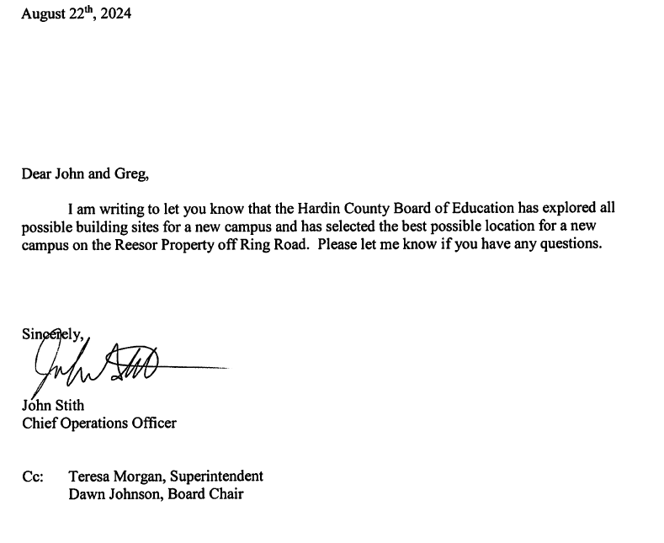

RECOMMENDATION:
i recommend that the Board APPROVE THE PROPERTY SEARCH LETTER TO KDE.

RECOMMENDED MOTION
I MOVE that the Board APPROVE THE PROPERTY SEARCH LETTER TO KDE.

