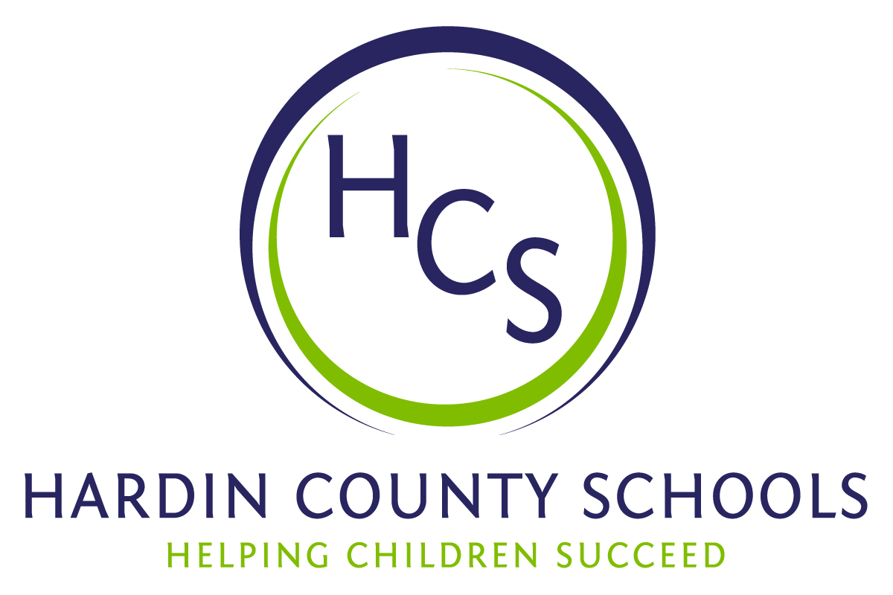
Board of Education
Dawn Johnson, Chair
Ben Sego, Vice Chair
Steve Bland
Mark Casey
Charlie Wise

Chief Academic Officer
Greg Sutton

Chief Operations Officer
John Stith

Teresa Morgan, Superintendent

Resolution of Recognition

WHEREAS, the function of a Board of Education is to strive for excellence in all phases of educational programs, and;

WHEREAS, a major indication of such excellence is awards and honors earned by the students, employees, and programs of the school system, and;

WHEREAS, the Hardin County Board of Education deems it fitting and proper that significant awards and honors be recognized by the Board;

BE IT THEREFORE RESOLVED THAT the Hardin County Board of Education, meeting in special session on October 17, 2024, does hereby recognize the achievements of the following:

- Gavin Daugherty, a James T. Alton Middle School sixth-grade student, has earned the Kentucky Yes I Can award for Self-Advocacy. In his nomination letter for the award, the author noted that Gavin is a remarkable student who has always wanted to have a choice in everything that he does. He likes to advocate for himself in what he wants to do. He is independent, helpful, and has the biggest heart. One will almost always find him sweeping his classroom or wiping tables because he has asked to do it. He asks to turn the board on in the mornings after he goes to get his breakfast. He will return the lunch trays to the cafeteria, put them on the counter to be washed, and return to the classroom by himself because he has made this his daily job. His work ethic is remarkable!
- Raven Turner, a Rineyville Elementary School third-grade student, has earned the Kentucky Yes I Can Award for Technology. In her nomination letter for the award, the author said that since Raven received her Augmentative and Alternative Communication “voice” (they are not called devices in her classroom) last school year, she has flourished. In a year's time, she was able to navigate through the pages to find the words she wants to use. Before getting her voice she communicated in her own way. Now that she has her voice, she has been flourishing in her ability to find the right words that she wants to relay.
- K’Jon Dawson, a North Hardin High School freshman, has earned the Kentucky Yes I Can Award for Academics. K’Jon has learned that adversity is one of life’s greatest teachers from a young age and has utilized those lessons in advocating for himself in learning about both content and life. K’Jon is an outstanding student who has demonstrated recognizable achievement by maintaining academic excellence, exhibiting school representation in a number of sports, and accepted a leadership role and a collaborative mentality on the North Middle School Student Council last year. He has an outstanding work ethic and inquisitive nature which has contributed to this pursuit of excellence. Despite the obstacles he is overcoming, he has maintained a positive attitude toward learning and a willingness to accept and act upon feedback to improve his learning in all areas.

The Board extends its congratulations to these students for the recognition they have earned for themselves and Hardin County Schools.

