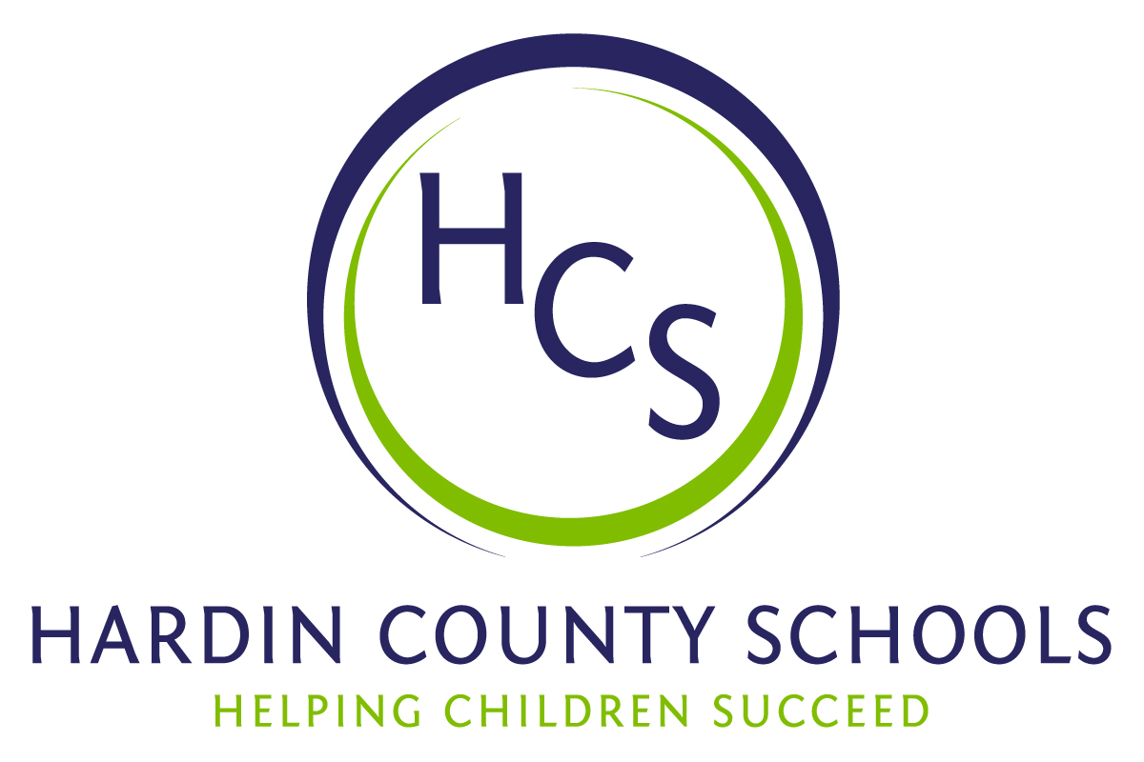
Board of Education
Dawn Johnson, Chair
Ben Sego, Vice Chair
Steve Bland
Mark Casey
Charlie Wise

Chief Academic Officer
Greg Sutton
Chief Operations Officer
John Stith

Teresa Morgan, Superintendent

Resolution of Recognition
#HCSDifferenceMaker Awards

WHEREAS, the function of a Board of Education is to strive for excellence in all phases of educational programs, and;

WHEREAS, the Hardin County Board of Education deems it fitting and proper that significant awards and honors be recognized by the Board, and;

WHEREAS, the Hardin County Board of Education believes in work ethic and the ability of students, staff and community members who dedicate themselves totally to the education of our next generation of leaders, and;

WHEREAS, the district’s theme for the 2024-25 school year is #HCSDifferenceMaker, and;

WHEREAS, #HCSDifferenceMaker stems from the five competencies of the Hardin County Schools Portrait of a Learner, and;

WHEREAS, those competencies are Responsible Citizen, Personal Champion, Engaged Learner, Effective Communicator and Active Collaborator, and;

WHEREAS, the Hardin County Board of Education believes in these characteristics so greatly that it will recognize HCS students, staff and Hardin County community members at its regularly scheduled meeting each month during the school year with the #HCSDifferenceMaker Award;

BE IT THEREFORE RESOLVED THAT the Hardin County Board of Education, in a regular meeting on October 17, 2024, does hereby recognize the following for earning the #HCSDifferenceMaker Award for October 2024:

- Noble Taylor, a Central Hardin High School sophomore, is a RESPONSIBLE CITIZEN. Noble helped rescue another student and the student’s parent from a car after it jumped a curb, hit a fire hydrant, and flipped on its side to avoid hitting another car. Noble helped them get out safely and got very wet from the spewing hydrant.”

- Carolyn Anderson, a Hardin County Schools bus driver, is a PERSONAL CHAMPION. Carolyn noticed that a young student was emotional on the bus ride to school. She took the time to find out why the student was upset and discovered she was grieving a family member. Carolyn then ensured the student’s emotional needs were communicated to the school by parking her bus and meeting with us directly. Her commitment to our students' well-being is a perfect example of how the difference is made right from the start of the school day.

- Leann Blair, a Central Hardin High School science teacher, is an ENGAGED LEARNER. A 2020 foreign exchange student recently returned to CHHS and visited with Ms. Blair. She shared that she decided to be a doctor while learning in Ms. Blair’s class. She told Ms. Blair that she had recently been accepted into medical school in Germany. Ms. Blair creates a classroom environment that pushes students academically while fostering a supportive culture that allows students to establish tremendous confidence.

- Brittany Rossell, a Vine Grove Elementary School special needs teacher, is an EFFECTIVE COMMUNICATOR. She advocates for all students and works hard to ensure they develop skills to be their best. Her trainings are phenomenal and all staff members come away with so many resources for their own classrooms. She also is involved in many community events with a mission to help everyone be their best.

- Sharon Hunt, a John Hardin High School special needs classroom instructional assistant is an ACTIVE COLLABORATOR. Ms. Hunt has worked with John Hardin High School special needs students at John Hardin High School for 24 years. She is extremely talented in working with low-incidence students. She goes above and well beyond the call of duty. She helps in many other ways. For example, she cleaned up after prom, set up senior dinner, and worked ball games. These are only a few ways of how Sharon collaborates at JHHS. She helps in any way she can but never seeks praise or attention.

