THIS IS A DECISION PAPER

TO: HARDIN COUNTY BOARD OF EDUCATION

FROM: Teresa Morgan, Superintendent

DATE: October 17, 2024

SUBJECT: APPROVAL OF BG 5 FOR THE EAST HARDIN MIDDLE CONSTRUCTION PROJECT

ISSUE: The Board needs to approve BG 5 to close out the two projects.

FACTS:

We are ready to close this project and complete the necessary paperwork per KDE regulations. The BG 5 details the expenses and revenues. The East Hardin Middle Project had a remaining balance of $ 1,442,574.98.

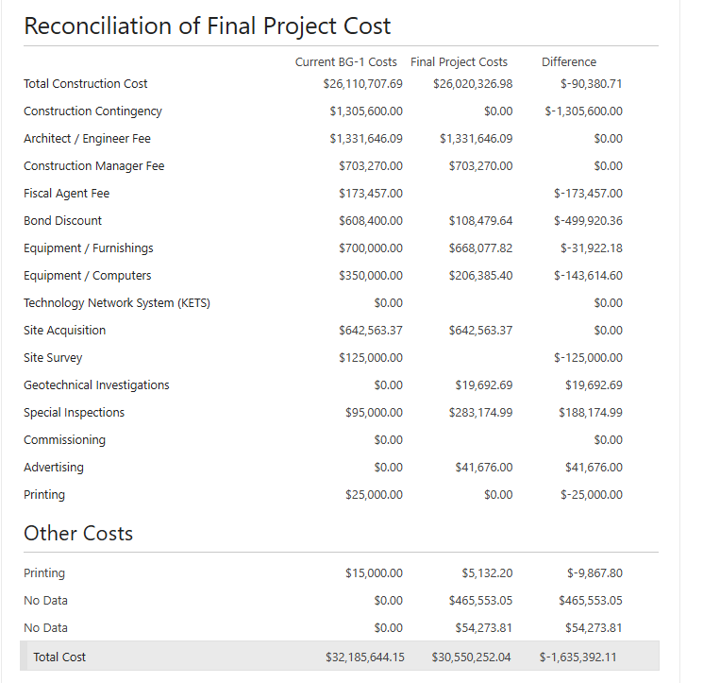
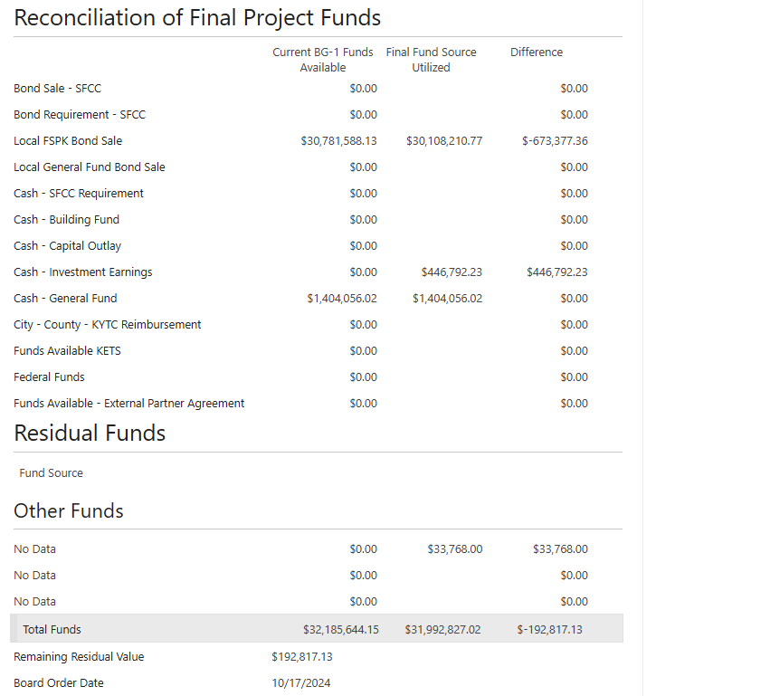

*See attached BG 5 and Munis Reports

RECOMMENDATION
I RECOMMEND THE BOARD APPROVE a BG 5 for the east HARDIN middle construction project

RECOMMENDED MOTION

I MOVE THE BOARD APPROVE a Bg 5 for the east HARDIN middle construction project

