THIS IS AN INFORMATION PAPER:
TO: Members of the Hardin County Board of Education
FROM: Teresa Morgan, Superintendent
DATE: October 17, 2024
SUBJECT: Carpet at the Central Office
DISCUSSION:
The carpet tiles at Central Office are nearing their life’s end. Attached is information on replacing most of them with new carpet tiles ( $ 95K) surrounded with vinyl tile ( $ 16.3K) walkways similar to our recent Media Center layout at new schools.
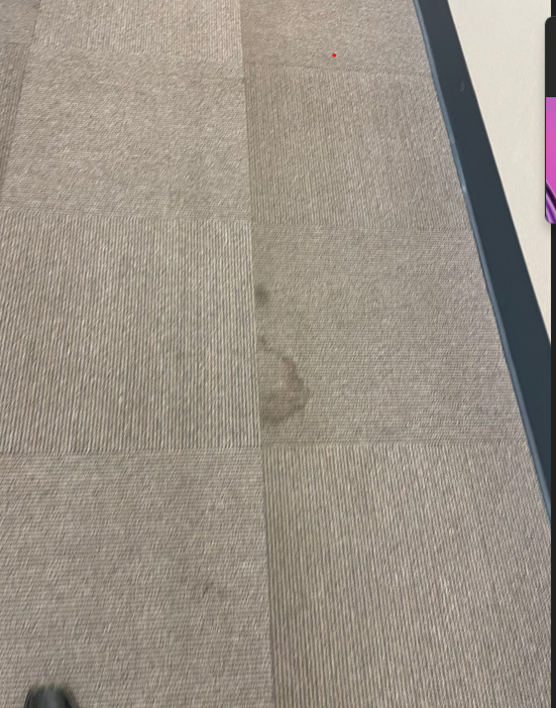

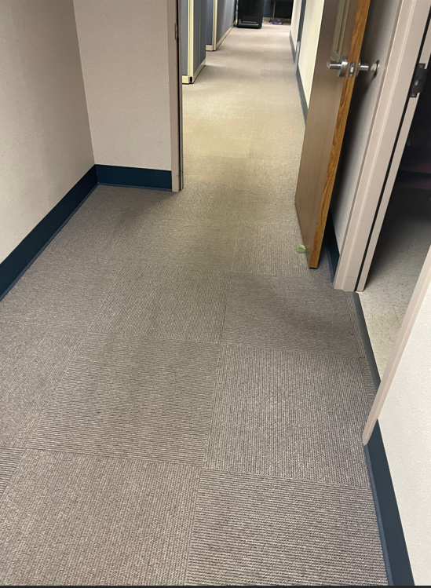
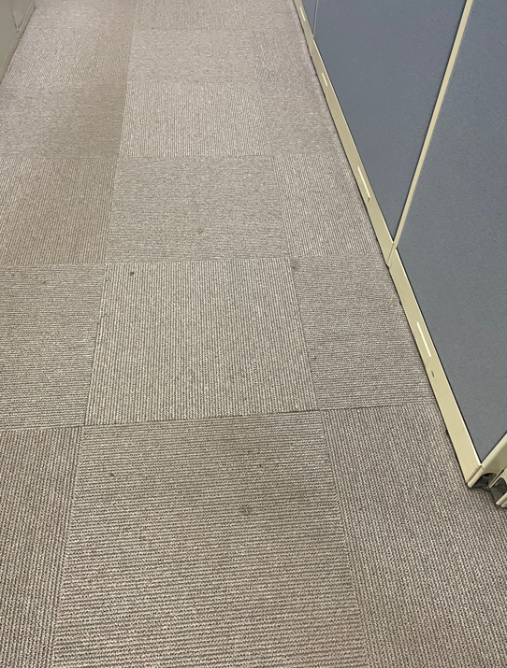
*See attached

