THIS IS A DECISION PAPER

TO: HARDIN COUNTY BOARD OF EDUCATION

FROM: Teresa Morgan, Superintendent

DATE: October 17, 2024

SUBJECT: APPROVAL OF CHANGE ORDERS 119-120 FOR THE CHHS PHASE 1 CONSTRUCTION PROJECT

ISSUE:
Change Orders 119 & 120 cancel each other out and are a result of charges between the ceiling grid and food service contractors.

FACTS:

CO 119

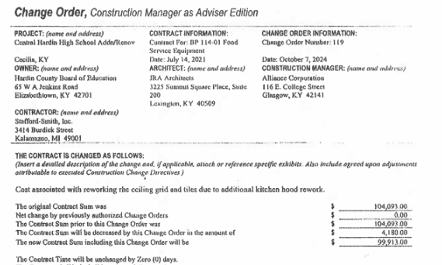

CO 120

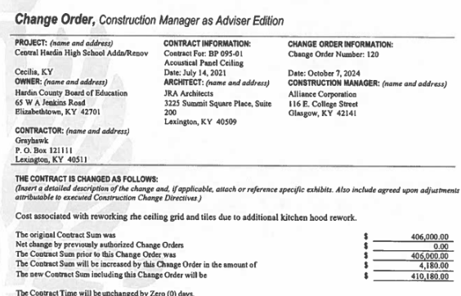

RECOMMENDATION
I RECOMMEND THE BOARD APPROVE CHANGE ORDERs 119-120 for the CHHS Phase 1 Construction project.

RECOMMENDED MOTION
I MOVE THE BOARD APPROVE CHANGE ORDERs 119-120 for the CHHS Phase 1 Construction project.

