THIS IS A DECISION PAPER

TO: HARDIN COUNTY BOARD OF EDUCATION

FROM: Teresa Morgan, Superintendent

DATE: October 17, 2024

SUBJECT: APPROVAL OF SITE CHANGE ORDERS 1 & 2 FOR THE CHHS TURF PROJECT

ISSUE:
Change Orders 1 and 2 are debits of $ 26,284.71 and $ 2,380.50 and are for costs associated with unsuitable soil in the field of play and repairs to a light pole.

FACTS:

CO 1

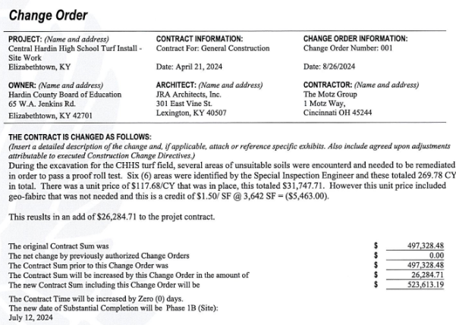

CO 2
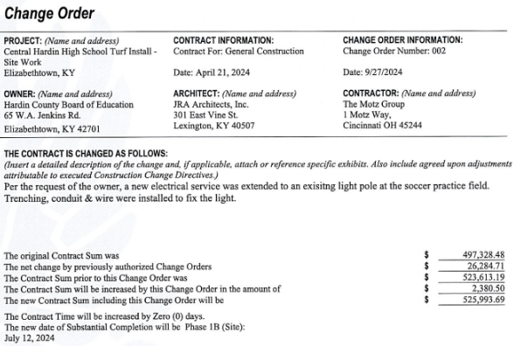

RECOMMENDATION
I RECOMMEND THE BOARD APPROVE CHANGE ORDERs 1 & 2 for the CHHS turf Construction project.

RECOMMENDED MOTION
I MOVE THE BOARD APPROVE CHANGE ORDERs 116-118 for the CHHS turf Construction project.

