THIS IS A DECISION PAPER

TO: HARDIN COUNTY BOARD OF EDUCATION

FROM: Teresa Morgan, Superintendent

DATE: October 17, 2024

SUBJECT: APPROVE BG 1 FOR A NEW NORTH PARK SCHOOL FROM THE DFP

ISSUE: KDE requires a BG 1 to begin the construction process.

FACTS
The current North Park Elementary School is at its end of life. In order to begin the process of replacing it, the board needs to initiate a BG 1. The BG 1 total is just under $ 40,000,000.

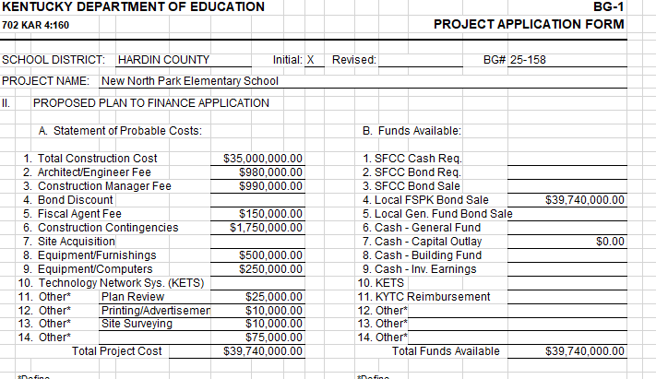

*See attached documents.

RECOMMENDATION
I RECOMMEND THE BOARD approve the bG1 for A nEW North Park SCHOOL.

RECOMMENDED MOTION

I MOVE THE BOARD approve the bG 1 for A NEW North Park SCHOOL.

