THIS IS A DECISION PAPER

TO: HARDIN COUNTY BOARD OF EDUCATION

FROM: Teresa Morgan, Superintendent

DATE: OCTOBER 17, 2024

SUBJECT: APPROVE A RESOLUTION TO ISSUE GENERAL OBLIGATION BONDS FOR THE NEW WEST HARDIN MIDDLE AND CHILD NUTRITION CONSTRUCTION PROJECTS NOT TO EXCEED 85 MILLION

ISSUE: THE BOARD NEEDS TO RAISE FUNDS FOR THESE TWO PROJECTS

FACTS:

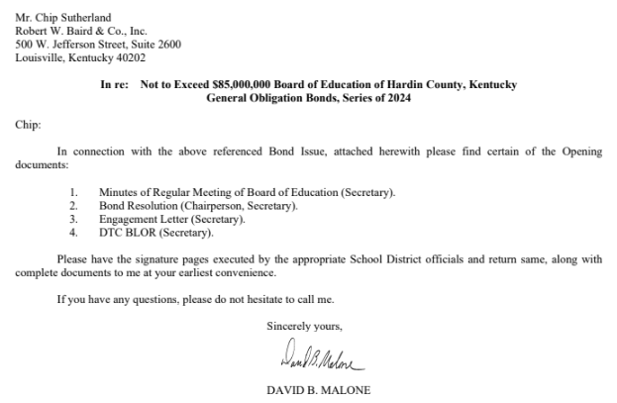

*See attached documents

RECOMMENDATION:
I recommend that the Board adopt the resolution to issue bonds not to exceed $85,000,000 for the purpose of constructing a new West HARDIN middle school and child nutrition facilities

RECOMMENDED MOTION
I MOVE that the Board adopt the resolution to issue bonds not to exceed $85,000,000 for the purpose of constructing a new West HARDIN middle school and child nutrition facilities.

