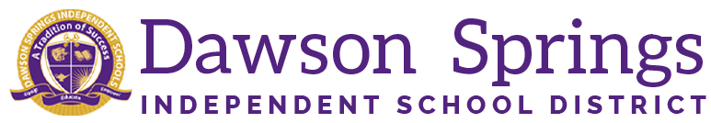

Dawson Springs Elementary School
Where the teachers and students give 100% every day and failure is not an option.
Panthers Prowling to Proficiency!

August 2024 Board Meeting
Elementary Principal Report
Jennifer Ward

- Academic Progress
  - CKLA is up and running smoothly. Teachers are meeting with Mrs. Amanda Cornell weekly to internalize their lessons for the next week. 4th and 5th grade teachers are meeting with Mrs. Ward to do the same planning.
  - iReady Fall screener has been completed for both reading and math

  - Adjustments are being made to the master schedule and certified instructional assistant schedules to help meet the individual needs of our students and classes.
  - Mrs. Hibbs is starting up our Check-In, Check-Out System again this year for PBIS and positive behaviors.
    - Allows quick connections to be made with our students before the day begins and right before they go home.
    - Classwork, grades, attendance, and behavior are monitored.
    - This program helped decrease absenteeism and boosted academic performance with those participating last year.
  - Kindergarten Brigance screener was conducted on September 17 and 18.
    - We are waiting on those scores to be completed in the system and then we will report to the board those results.
  - The Kentucky Department of Education (KDE) is proud to announce the first recipients of our annual State Recognition of Fidelity of Positive Behavior Interventions & Supports (PBIS) for schools, successfully implementing PBIS, during the 2023-24 school year. Based upon their level of implementation at fidelity, as defined in our State Recognition of Fidelity Standards, Dawson Springs Elementary has earned a Bronze recognition status for the 2023-24 school year. Congratulations for your outstanding efforts to improve climate and culture through the implementation of PBIS
- PLC Conversations for the Month:
  - Grades K-3 teachers meet weekly with Amanda Cornell, Literacy Specialist, for CKLA guided planning. 4 and 5th grade teachers meet with Mrs. Ward.
  - DSES is going to start a book study next week called Focus Elevating the Essentials to Radically Improve Student Learning BY Mike Schmoker.

- Upcoming Events:
  - August 28 is the PTO meeting at 6 PM in the MPR
    - This will be the meeting to claim your Fall Festival Booth
  - September 17 will be Parent Teacher conferences

