THIS IS A DECISION PAPER

TO: HARDIN COUNTY BOARD OF EDUCATION

FROM: Teresa Morgan, Superintendent

DATE: SEPTEMBER 24, 2024

SUBJECT: APPROVAL BG 4 FOR BID PACKAGE 084 FOR THE EAST HARDIN MIDDLE PROJECT

ISSUE:
KDE requires BG 4’s for each contract on the construction project. Roger’s Aluminum and Glass was bought out by Lake Cumberland Glass and this contract was inadvertently removed from FACPAC

FACTS:

BG 4

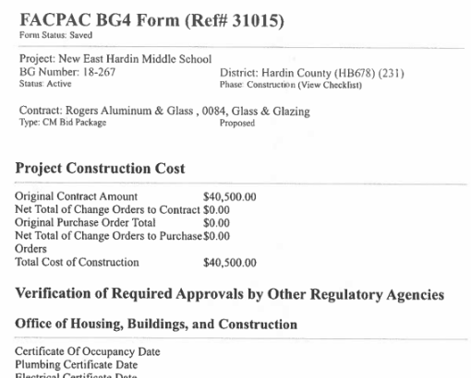

RECOMMENDATION
I RECOMMEND THE BOARD APPROVE the BG 4 for bid package 084 for the east Hardin middle project.

RECOMMENDED MOTION
I MOVE THE BOARD APPROVE the BG 4 for bid package 084 for the east Hardin middle project.

