THIS IS A DECISION PAPER

TO: HARDIN COUNTY BOARD OF EDUCATION

FROM: TERESA MORGAN, Superintendent

DATE: SEPTEMBER 5, 2024

SUBJECT: NEW WEST HARDIN MIDDLE CONSTRUCTION PROJECT

ISSUE: CONSIDERATION OF NEW WEST HARDIN MIDDLE CONSTRUCTION BIDS

FACTS:

KDE requires boards to approve construction bids to proceed with a project. Total Construction Cost totaled $ 57,709,384.04

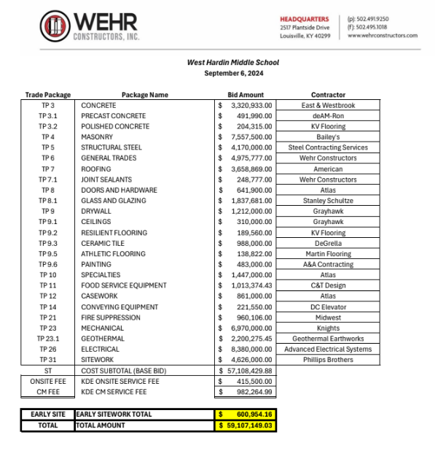
*See attached Docments

RECOMMENDATION:

i recommend that the Board award contracts for THE bid packages as RECOMMENDED by Wehr and JRA including all the alternates for the nEW wEST hardin mIDDLE construction project. Furthermore, the board authorizes WEHR to aggressively negotiate on its behalf the final bid price for bid packages TP3 and TP4 with East and Westbrook and Bailey’s Masonry to complete the corresponding REvised BG 1 for the construction project.

RECOMMENDED MOTION
I move that the Board award contracts for THE bid packages as RECOMMENDED by Wehr and JRA including all the alternates for the nEW West Hardin mIDDLE construction project. Furthermore, the board authorizes WEHR to aggressively negotiate on its behalf the final bid price for bid packages TP3 and TP4 with East and Westbrook and Bailey’s Masonry to complete the corresponding REvised BG 1 for the construction project.

