THIS IS A DECISION PAPER

TO: HARDIN COUNTY BOARD OF EDUCATION

FROM: Teresa Morgan, Superintendent

DATE: SEPTEMBER 19, 2024

SUBJECT: APPROVAL OF CHANGE ORDER 1 FOR THE WEST HARDIN MIDDLE CONSTRUCTION PROJECT

ISSUE:
Change Order 1 is a debit of $ 23,513 for costs associated with unsuitable soil.

FACTS:

CO 1

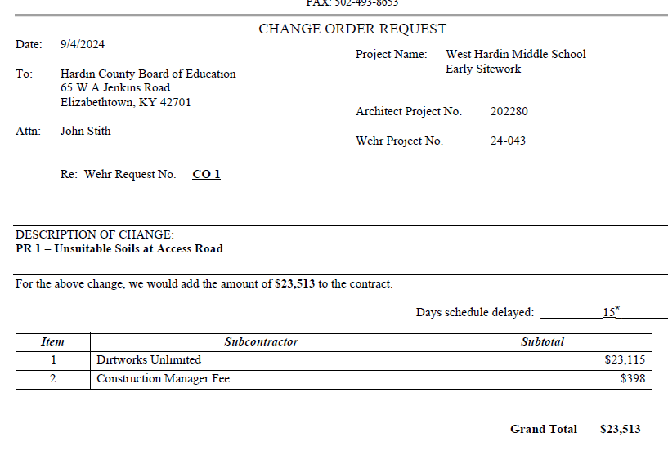

RECOMMENDATION
I RECOMMEND THE BOARD APPROVE CHANGE ORDER 1 for the WEST HARDIN MIDDLE Construction project.

RECOMMENDED MOTION
I MOVE THE BOARD APPROVE CHANGE ORDER 1 FOR THE WEST HARDIN MIDDLE CONSTRUCTION project.

