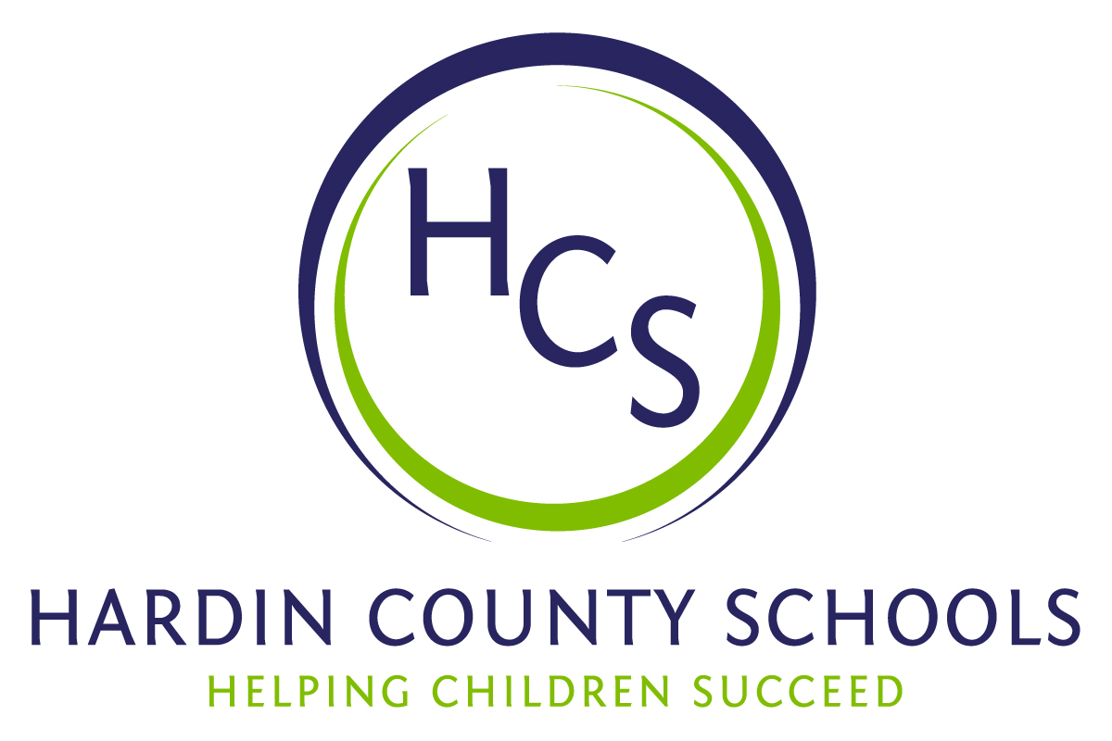
Board of Education
Dawn Johnson, Chair
Ben Sego, Vice Chair
Steve Bland
Mark Casey
Charlie Wise

Chief Academic Officer
Greg Sutton
Chief Operations Officer
John Stith

Teresa Morgan, Superintendent

Resolution of Recognition
#HCSDifferenceMaker Awards

WHEREAS, the function of a Board of Education is to strive for excellence in all phases of educational programs, and;

WHEREAS, the Hardin County Board of Education deems it fitting and proper that the Board recognize significant awards and honors, and;

WHEREAS, the Hardin County Board of Education believes in work ethic and the ability of students, staff, and community members who dedicate themselves totally to the education of our next generation of leaders, and;

WHEREAS, the district’s theme for the 2024-25 school year is #HCSDifferenceMaker, and;

WHEREAS, #HCSDifferenceMaker stems from the five competencies of the Hardin County Schools Portrait of a Learner, and;

WHEREAS, those competencies are Responsible Citizen, Personal Champion, Engaged Learner, Effective Communicator and Active Collaborator, and;

WHEREAS, the Hardin County Board of Education believes in these characteristics so greatly that it will recognize HCS students, staff, and Hardin County community members at its regularly scheduled meeting each month during the school year with the #HCSDifferenceMaker Award;

BE IT THEREFORE RESOLVED THAT the Hardin County Board of Education, in a regular meeting on September 19, 2024, does hereby recognize the following for earning the #HCSDifferenceMaker Award for September 2024:

- Lennox Alderman, a Radcliff Elementary School student, is a RESPONSIBLE CITIZEN. During a medical emergency in his classroom, Lennox remained calm and took charge. He called the office and told the staff that his teacher needed help. Lennox took it upon himself to do this. His quick response led to his teacher getting the medical help she needed promptly.

Brody Hart, a Lincoln Trail Elementary School, is a PERSONAL CHAMPION. Brody contributes to the LTES school community in many positive ways. His fellow students feel empowered and important when talking with Brody. He embodies the LTES ROAR matrix every day. He is selfless in his actions, motivational in his speaking, and inspiring in his endurance. Brody is a wonderful student and personal champion for all he encounters.

Mackenzie Logan, a North Hardin High School senior, is an ENGAGED LEARNER Mackenzie is the company commander of the NHHS JROTC. She is genuinely interested in helping others and provides services in a positive and caring manner. During her four years in JROTC, Mackenzie has either led or participated in four JROTC extracurricular teams. As a member of JROTC, she participates in marksmanship, color guard, drill, Raiders, J-Lab, and the honor guard.

- Alison Kimble, a Meadow View Elementary School teacher, is an EFFECTIVE COMMUNICATOR. Ms. Kimble taught Safe Crisis Management for the district where her impact extended far beyond simply conveying the material. She demonstrated an outstanding ability to communicate the teacher's role during crises, emphasizing the crucial importance of protecting each student's dignity. Ms. Kimble’s positivity was contagious. She has a deep passion for the students she serves.

- Clay Smith, the owner of Smith Family Homes is an ACTIVE COLLABORATOR. Clay Smith was a leader in the construction of an AgSTREAM outdoor classroom at Creekside Elementary School. Mr. Smith volunteered his time, equipment, and resources to get the project started and to make the outdoor classroom a reality. Without Mr. Smith's leadership and collaboration, the outdoor classroom would not be the beautiful addition it is for the students at Creekside Elementary.

