THIS IS A DECISION PAPER

TO: HARDIN COUNTY BOARD OF EDUCATION

FROM: teresa morgan, Superintendent

DATE: September 15th, 2024

SUBJECT: APPROVAL OF CHANGE ORDERS 116-118 FOR THE CHHS PHASE 1 CONSTRUCTION PROJECT

ISSUE:
Change Orders 116 and 117 are debits of $ 8,720.10 and $ 31,519.50 and are for costs associated with unsuitable soil in the main entrance drive lane and repairs to the small gym floor. CO 118 is a credit of $ 42,244.50 and is reimbursement to the board for the small gym repairs and depreciation of the floor.

FACTS:

CO 116

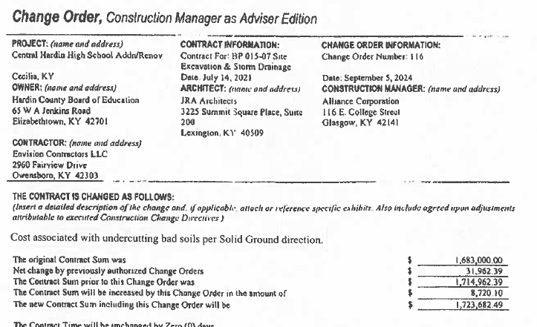

CO 117

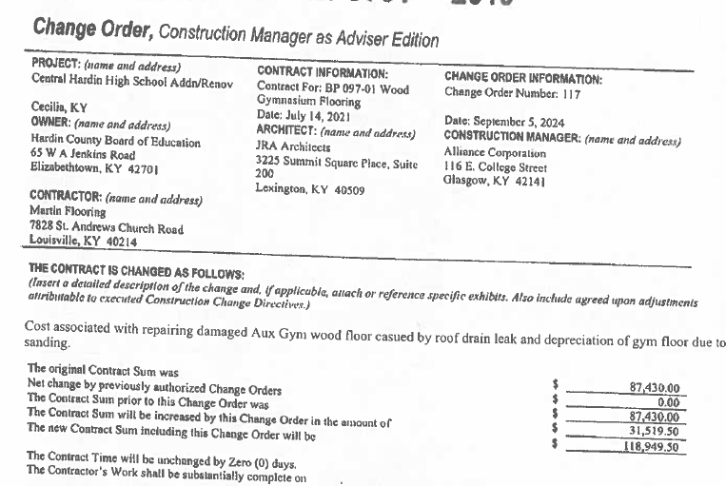

CO 118
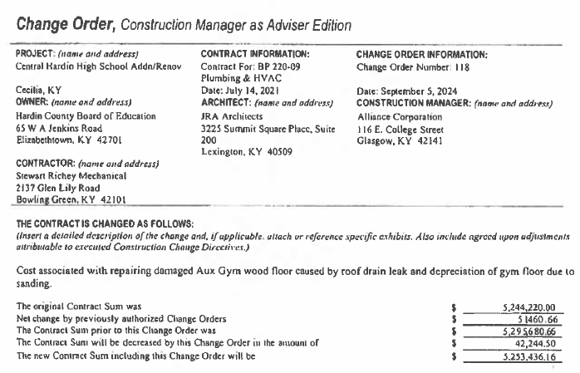

RECOMMENDATION
I RECOMMEND THE BOARD APPROVE CHANGE ORDERs 116-118 for the CHHS Phase 1 Construction project.

RECOMMENDED MOTION
I MOVE THE BOARD APPROVE CHANGE ORDERs 116-118 for the CHHS Phase 1 Construction project.

