THIS IS A DECISION PAPER

TO: HARDIN COUNTY BOARD OF EDUCATION

FROM: Teresa Morgan, Superintendent

DATE: September 16TH, 2024

SUBJECT: APPROVAL OF BG 5’s FOR THE EAST MIDDLE AND CECILIA VALLEY CONSTRUCTION PROJECTS.

ISSUE: The Board needs to approve BG 5 to close out the two projects.

FACTS:

We are ready to close these projects and complete the necessary paperwork per KDE regulations. The BG 5 details the expense and revenues. The East Middle Project had a remaining balance of $ 1,442,574.98 and the Cecilia Valley Project had a remaining balance of $ 1,990,650.87.

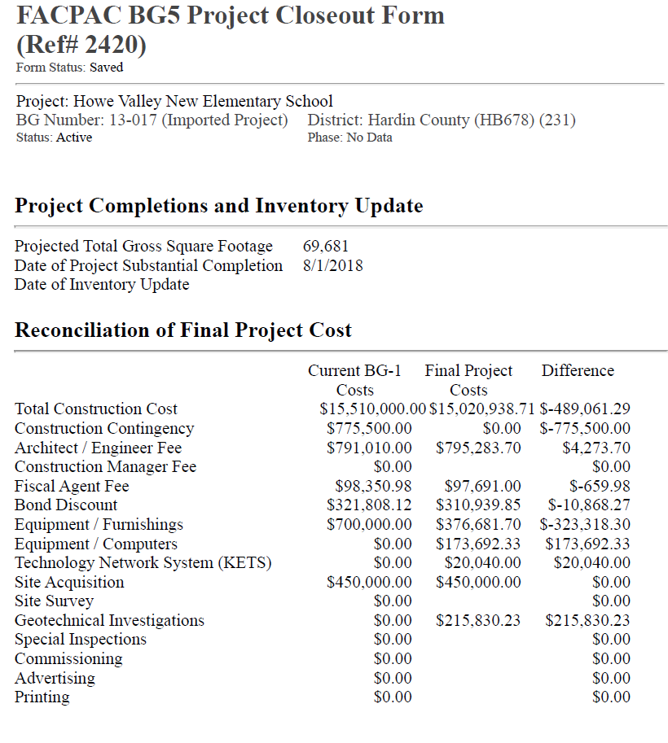

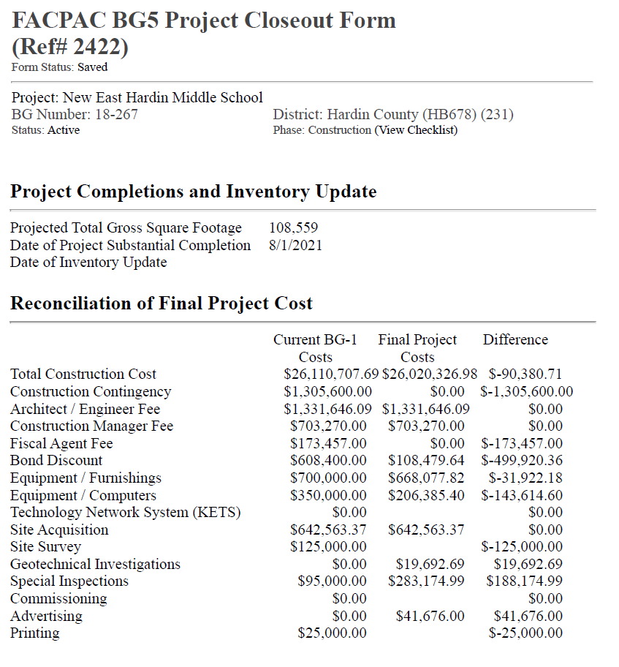

*See attached BG 5’s and Munis Reports

RECOMMENDATION
I RECOMMEND THE BOARD APPROVE a BG 5’s for the east middle and cecilia valley construction projects

RECOMMENDED MOTION

I MOVE THE BOARD APPROVE a Bg 5’s for the east middle and cecilia valley construction projects

