THIS IS A DECISION PAPER

TO: HARDIN COUNTY BOARD OF EDUCATION

FROM: Teresa Morgan, Superintendent

DATE: SEPTEMBER 5, 2024

SUBJECT: APPROVAL BG 4s Site and Surface for the JHHS Turf Projects

ISSUE:
KDE requires BG 4s to begin closing out a project. All the work is complete and the fields look great.

FACTS:

BG 4’s

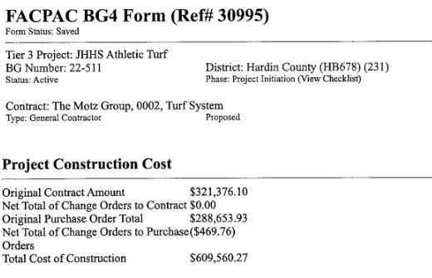

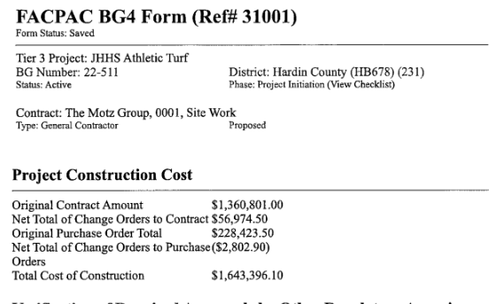

RECOMMENDATION
I RECOMMEND THE BOARD APPROVE and BG 4s for the JHHS turf project.

RECOMMENDED MOTION
I MOVE THE BOARD APPROVE BG 4s for the JHHS Turf project.

