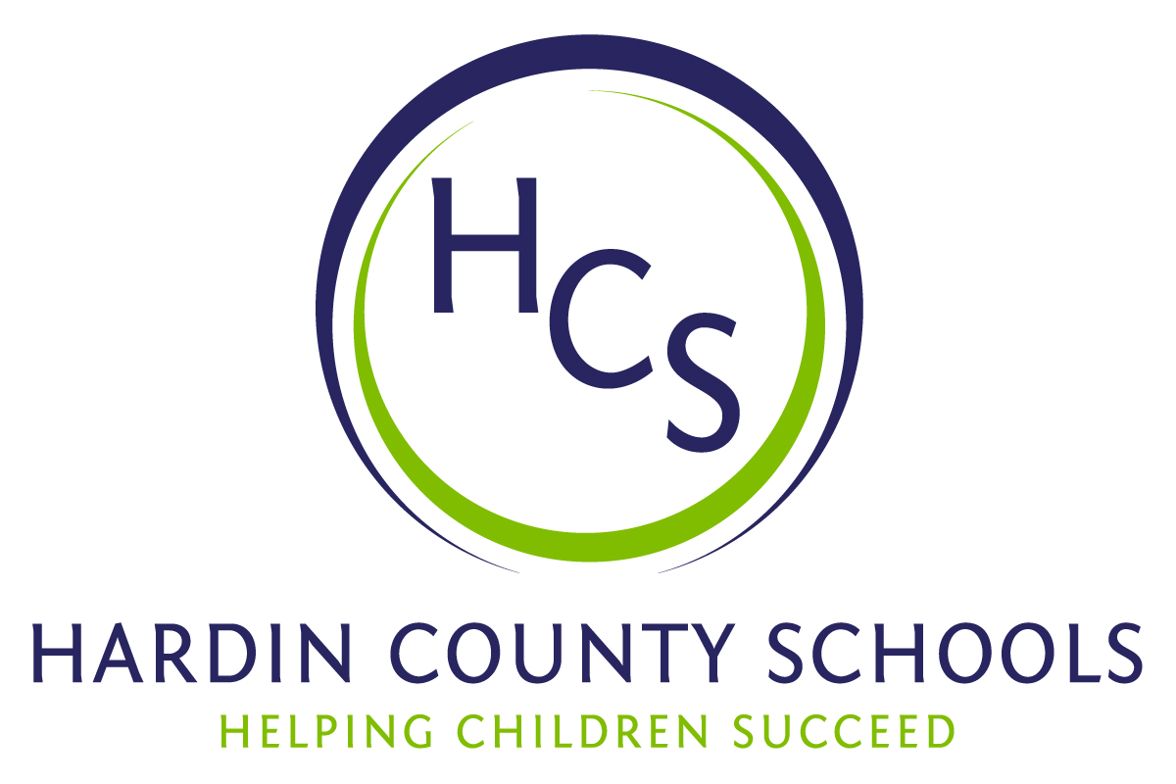
Board of Education
Dawn Johnson, Chair
Ben Sego, Vice Chair
Steve Bland
Mark Casey
Charlie Wise

Chief Academic Officer
Greg Sutton
Chief Operations Officer
John Stith

Teresa Morgan, Superintendent

Resolution of Recognition
#HCSDifferenceMaker Awards

WHEREAS, the function of a Board of Education is to strive for excellence in all phases of educational programs, and;

WHEREAS, the Hardin County Board of Education deems it fitting and proper that the Board recognize significant awards and honors, and;

WHEREAS, the Hardin County Board of Education believes in work ethic and the ability of students, staff, and community members who dedicate themselves totally to the education of our next generation of leaders, and;

WHEREAS, the district’s theme for the 2024-25 school year is #HCSDifferenceMaker, and;

WHEREAS, #HCSDifferenceMaker stems from the five competencies of the Hardin County Schools Portrait of a Learner, and;

WHEREAS, those competencies are Responsible Citizen, Personal Champion, Engaged Learner, Effective Communicator and Active Collaborator, and;

WHEREAS, the Hardin County Board of Education believes in these characteristics so greatly that it will recognize HCS students, staff, and Hardin County community members at its regularly scheduled meeting each month during the school year with the #HCSDifferenceMaker Award;

BE IT THEREFORE RESOLVED THAT the Hardin County Board of Education, in a regular meeting on August 15, 2024, does hereby recognize the following for earning the #HCSDifferenceMaker Award for August 2024:

- April Frye and Neil Cardin, HCS bus drivers, are ACTIVE COLLABORATORS. On the evening of June 21, a group was stranded with a broken-down bus on Interstate 65 in Hardin County. One of the passengers was a school teacher in her native Louisiana. A few internet searches led her to the inbox of HCS Superintendent Teresa Morgan. Mrs. Morgan made a few phone calls and that is where Neal Cardin and April Frye came into the picture. Well up into a summer’s night, these two received a phone call asking them to make the rescue of these strangers but friends we didn’t have. Neal and April took their new friends to a hotel, their bus issues were soon resolved and the passengers quickly went on their way. But, Neal and April truly saved the day for many weary travelers because they embody the HCS spirit.

- Paula Crowder, Cecilia Valley Elementary School custodian, is a RESPONSIBLE CITIZEN. CVES Principal Casey Goodman says, "Paula is one of the hardest workers in the school. She takes pride in her work and encourages others to do their best. Paula is the first to jump in and help solve problems. She puts others before herself and does everything she can to keep our school looking vibrant and beautiful! She builds strong relationships and often finds new ways to motivate students.”

- Carl Smalls, pastor at Restoration Church, is a PERSONAL CHAMPION of all students at Bluegrass Middle School. His support of the school is wide-ranging from attending athletic events and cheering our students on to substitute teaching in the building at the drop of a hat. Carl is the embodiment of HCS pride. BGMS Principal Mark Webster said that his school is honored that he is a part of the school’s community. Mr. Webster noted that, “Pastor Smalls not only trusts us with his children but with his time as well.”

- Bridgit Alicna, a Central Hardin High School freshman, is an ENGAGED LEARNER, because of her work in overcoming obstacles to pursue her dream. After the diagnosis of a medical condition, she underwent spine surgery. Norton Children’s Hospital says that she was the first in Kentucky to receive spinal surgery using new computer navigation technology. Bridgit’s goal is to be ready to perform in a local production of The Nutcracker this year. Bridgit said that when she was younger, she really wanted to teach gymnastics. But at the summer dance camp, she found a connection to dance. She added “There were times I wanted to quit, but I didn’t and I’m glad I didn’t. It’s a connection with your whole body. You’re energized and doing these things that are good for you and you also have a connection with the studio and your family and all the friends there.”

- Benjamin Updegraff, a John Hardin High School senior, is an EFFECTIVE COMMUNICATOR because of his work in earning Eagle Scout status as a member of the Boy Scouts of America. In a recent interview with The News-Enterprise, he noted that “It took a lot of time, working with others and getting a lot of hard stuff done, and it took a lot of dedication, but the more work you put in, the more rewarding it was.” He has also served as an aide in the John Hardin media center and is the 2024-25 President of the school’s FFA Chapter. Library Media Center Aurora Selbe said that Benjamin is “very devoted to his fellow FFA members and has spent many hours promoting his teammates on social media and helping them succeed in the program. He is a selfless leader who wants to see his teammates succeed before his own personal success. This is what will make him an excellent President of the John Hardin chapter of FFA.”

- Craig Buchanan, the Family Resource Center Coordinator at Radcliff Elementary School is an ACTIVE COLLABORATOR. Principal Dan Mahon said that Craig has been instrumental in getting community members to come into our school and help. Just recently, Craig arranged for community members to not only donate mulch to our playground but also help spread it. On Opening Day, Craig volunteered to cook hamburgers for the staff so that teachers could finish working in their rooms.

