THIS IS A DECISION PAPER

TO: HARDIN COUNTY BOARD OF EDUCATION

FROM: TERESA MORGAN

DATE: SEPTEMBER 5, 2024

SUBJECT: ADDITIONAL INSURANCE COVERAGES

ISSUE

The optional additional coverages for the insurance policy for the Hardin County Schools needs to be approved.

FACTS

See letter from insurance consultant Keith Riley.

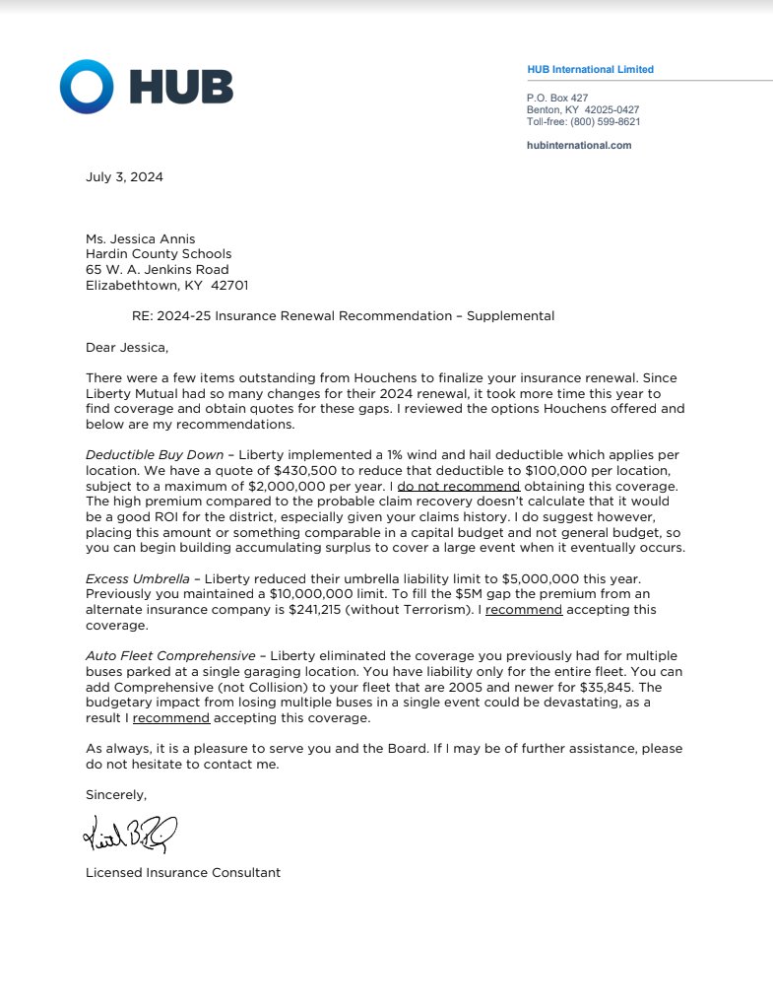

RECOMMENDATION

I RECOMMEND THE HARDIN COUNTY BOARD OF EDUCATION APPROVE THE ADDITIONAL INSURANCE TO ADD COMPREHENSIVE TO AUTO POLICY WITH HOUCHENS INSURANCE GROUP AS PRESENTED.

RECOMMENDED MOTION

I MOVE THAT THE HARDIN COUNTY BOARD OF EDUCATION APPROVE THE ADDITIONAL INSURANCE TO ADD COMPREHENSIVE TO AUTO POLICY WITH HOUCHENS INSURANCE GROUP AS PRESENTED.

