THIS IS A DECISION PAPER

TO: Hardin County Board Of Education

FROM: TERESA MORGAN

DATE: AUGUST 28, 2024

SUBJECT: 2024-2025 Tax Rates

ISSUE

The Board needs to approve the tax rates for the 2024-2025 school year. The Board must consider the economic factors such as inflation on items such as gas, food, and utilities. The Board needs to consider keeping competitive wages in order to obtain and employ quality employees.

FACTS

The assessment values for 2024-2025 are projected at $8,690,423,154 which results in a net assessment of growth of $714,689,882 from real and personal property. Motor vehicle assessments are $1,029,253,305 a net growth of $65,887,829 for a total assessment value of $9,719,676,459. Normally, we see an increase in assessment values at $200,000,000. When assessments have a higher increased value, the local tax rates need to increase to offset reduced state funding levels. Due to higher assessments, HCS will see approximately a reduced SEEK of $2,341,733 from final FY24 SEEK.

Item | Net Assessment Growth
Real Estate | $644,804,571
P.S. Co – Real Estate | -$9,770,999
P.S. Co- Personal Property | $18,489,520
Personal Property | $61,633,922
Distilled Spirits | -$467,132
Motor Vehicle | $65,887,829

The Board may choose to adopt the following for 2024-2025:

The current tax rate (same rate as FY24) for GF Real Estate will be 65.2 per $100 of assessment value and will yield $46,585,347. An increase of revenue of approximately $4,007,534 (including growth and new property) from the previous year’s rate if 100% of taxes are collected.

The current tax rate (same rate as FY23) for GF Personal Property will be 65.2 per $100 of assessment value and could yield $5,549,319. An increase of revenue of approximately $519,360 (including growth and new property) from the previous year’s rate if 100% of taxes are collected.

- This rate does require a hearing, - is subject to recall.KRS160.470
- 5.8 cents of the total property rate shown above is required to produce the 5 cent equivalent tax necessary for participation in the SFCC and FSPK programs

- Total Revenue $4,526,894 less SEEK reduction ($2,341,733) = NET REVENUE $2,185,161

The Motor Vehicle Tax Rate for 2025 will remain at the 54.0 level. This tax rate cannot be changed. Motor Vehicle Tax Rates cannot exceed the previous year’s rate of 54 cents or the Tier 1 level. The current Tier 1 level is at .45 cents.

The gross utilities receipts tax rate would continue to be 3% (the same rate since 1966).

Further, the Board needs to continue the taxation on the aircraft (recreational and non-commercial) and watercraft (Non-commercial out-of-state or Coast Guard registered).

RECOMMENDATION

I recommend the Board approve the proposed adoption of real property tax rate of 65.2 cents per $100 of property which is the current tax rate, a personal property tax rate of 65.2 cents per $100 of property which is the current tax rate, a motor vehicle rate of 54.0 cents per $100 property, and a gross utilities tax rate of 3% and taxation of the aircraft and watercraft personal property.

RECOMMENDED MOTION

I move that the Hardin County Board of Education approve the proposed adoption of real property tax rate of 65.2 cents per $100 of property which is the current tax rate, a personal property tax rate of 65.2 cents per $100 of property which is the current tax rate, a motor vehicle rate of 54.0 cents per $100 property, and a gross utilities tax rate of 3% and taxation of the aircraft and watercraft personal property.

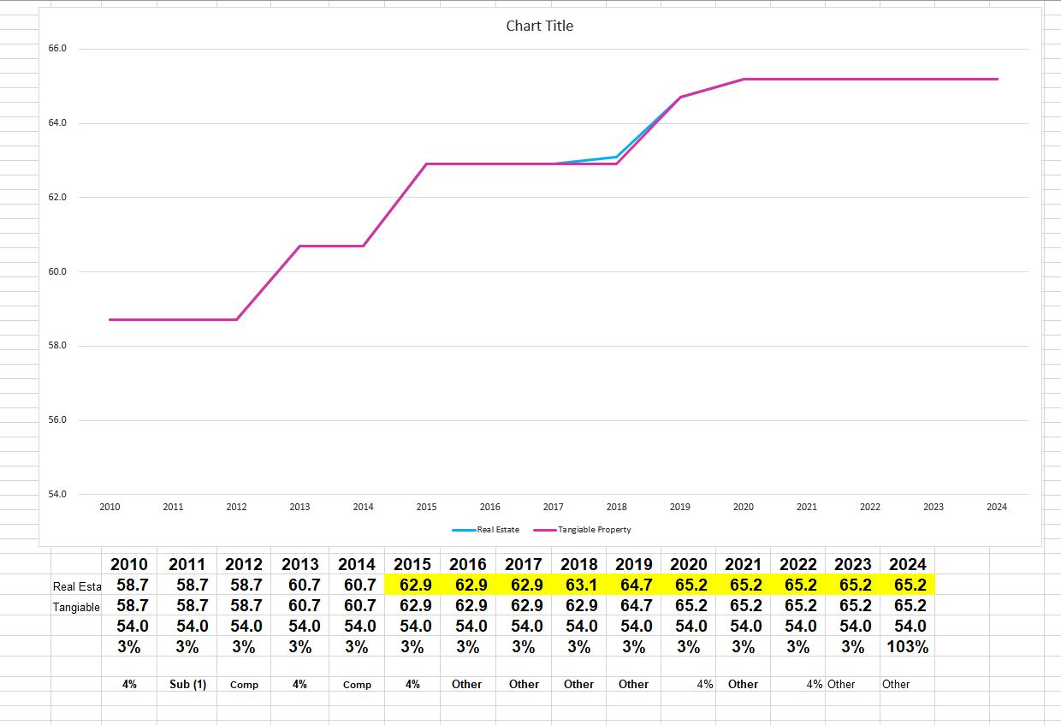

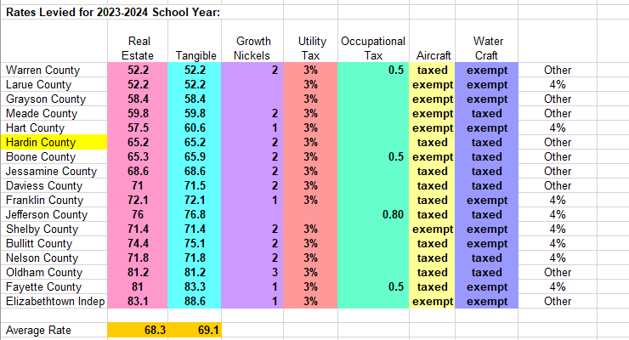
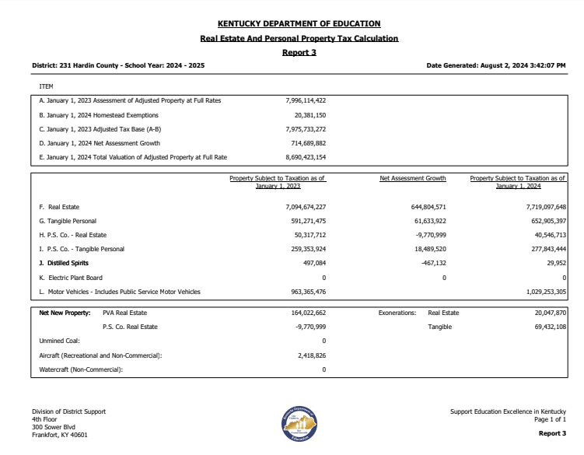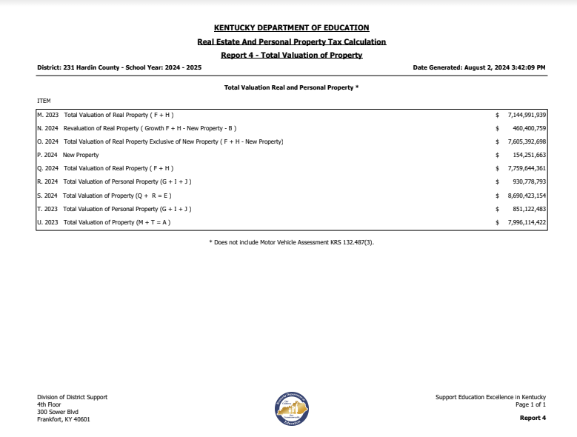

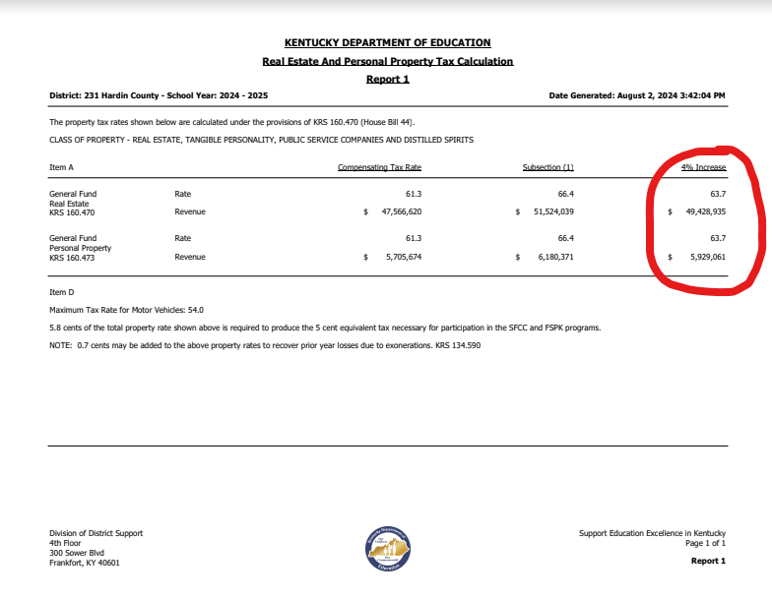

- 4% increase rate will net revenue from FY24 of $ 3,229,330 less SEEK reduction of $2,341,733 net revenue = $ 887,597

