THIS IS A DECISION PAPER

TO: HARDIN COUNTY BOARD OF EDUCATION

FROM: Teresa Morgan, Superintendent

DATE: JULY 29, 2024

SUBJECT: APPROVAL OF LEASE AGREEMENT WITH MOVERET

ISSUE:
MOVERET, Inc, a Georgia-incorporated company, has inquired about leasing the old East kitchen for the purpose of serving meals to workers at the BOSK plant in Glendale.

FACTS:

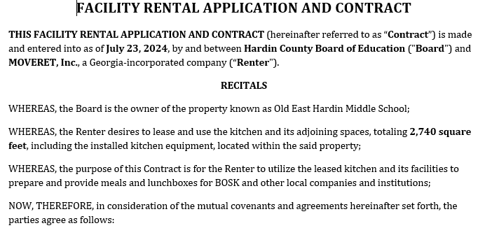

RECOMMENDATION
I RECOMMEND THE hardin county BOARD of education APPROVE the lease agreement with Moveret, inc.

RECOMMENDED MOTION
I MOVE THE hardin county BOARD of education approve the lease agreement with moveret, inc.

