GES Monthly Board Report
July 2024 - Susan Short

THANK YOU, BOE MEMBERS, FOR ALL YOU DO FOR BISD!

Personnel:
- Current Vacancies
  - PE Teacher
  - K Teacher
  - Instructional Assistant
Construction:
- All classrooms have been relocated to the main floor of GES.
- Second floor is currently under construction with ceiling tiles being removed.
- Gym area in the back has been leveled and marked off.
- Pictures are included below.

Hubbard’s Cubbard
- Rob Sanders has been working closely with the Sam Hubbard Foundation in having a “Hubbard’s Cupboard” installed at Grandview Elementary School.
- The Cupboard was installed on July 10th, and will provide easy access for clothing, toiletries, food, and other essential items for students and families of Grandview to use. The foundation will check on the supplies regularly to ensure that items are always available.
- The cupboard is located on C-Level next to the stairs.

Instruction/Curriculum:
- GES’ new ELA curriculum resource, Wonders, was delivered today.
- We have been meeting with Allison Roth, our State Literacy Coaching Specialist, to begin planning how she will support our teachers in the implementation of this new curriculum. She is excited and looking forward to working with everyone at GES!
UPCOMING DATES FOR GES:
- July 30-31: Restraint and Seclusion Training
- August 1: NKU Safety Training
- August 5: New Teacher / Employee Onboarding
- August 6: NKCES is presenting on PBIS
- August 7: Wonders training for GES teachers; Back to School Bash

CONSTRUCTION PICTURES:
Gym area:
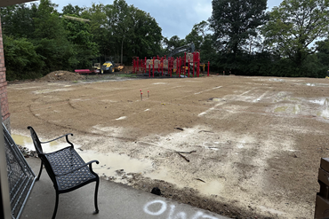
Hallway to the Commons:
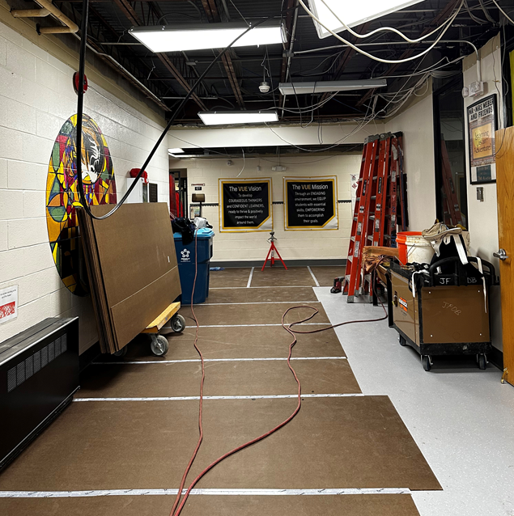
2nd Floor Classrooms:
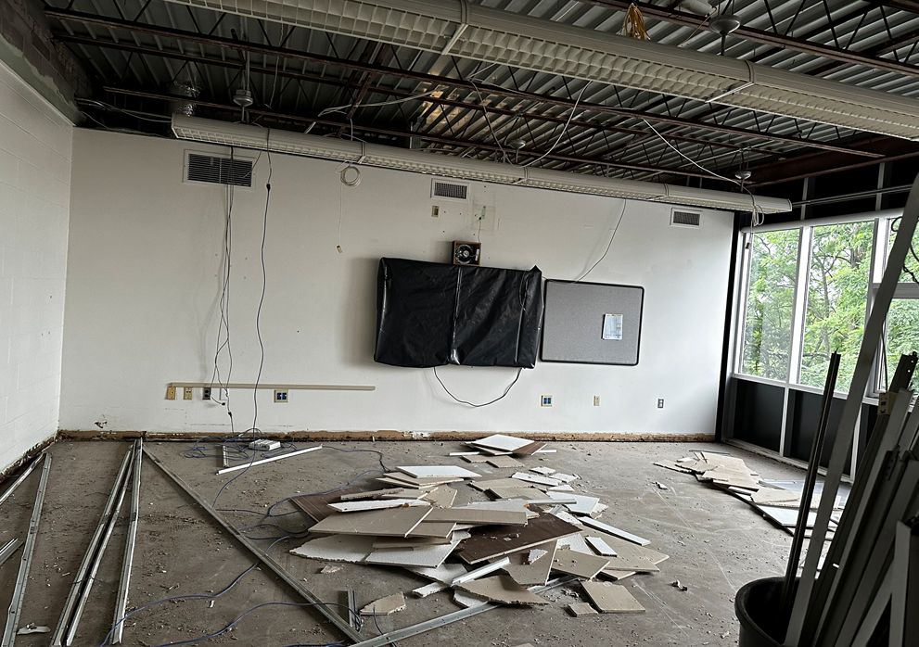
Main floor hallway:
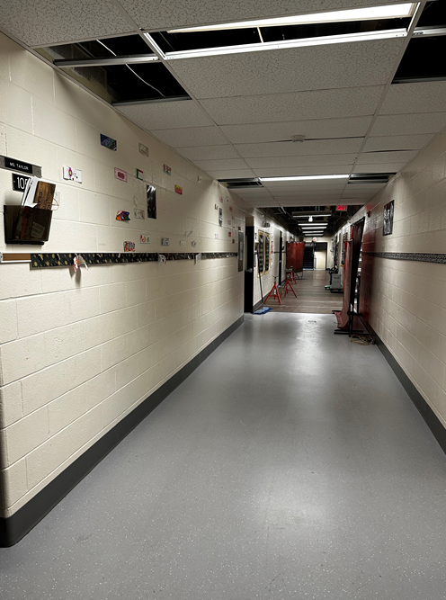

1st Floor classrooms are getting closer to being ready!
