THIS IS A DECISION PAPER

TO: HARDIN COUNTY BOARD OF EDUCATION

FROM: Teresa Morgan, Superintendent

DATE: May 16, 2024

SUBJECT: APPROVAL COPIER RFP

ISSUE:
Our Copier Fleet is ready to be replaced.

FACTS:

Price Info:
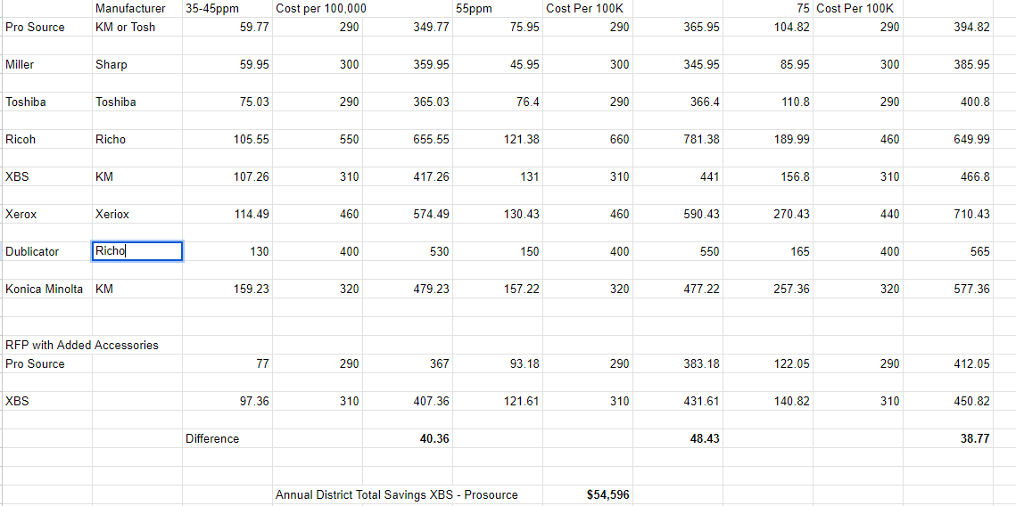

*See attached scoring rubric

RECOMMENDATION
I RECOMMEND THE hardin county BOARD of education APPROVE the Pro-Source RFP for Copiers.

RECOMMENDED MOTION
I MOVE THE hardin county BOARD of education APPROVE THE Pro-Source RFP for copiers.

