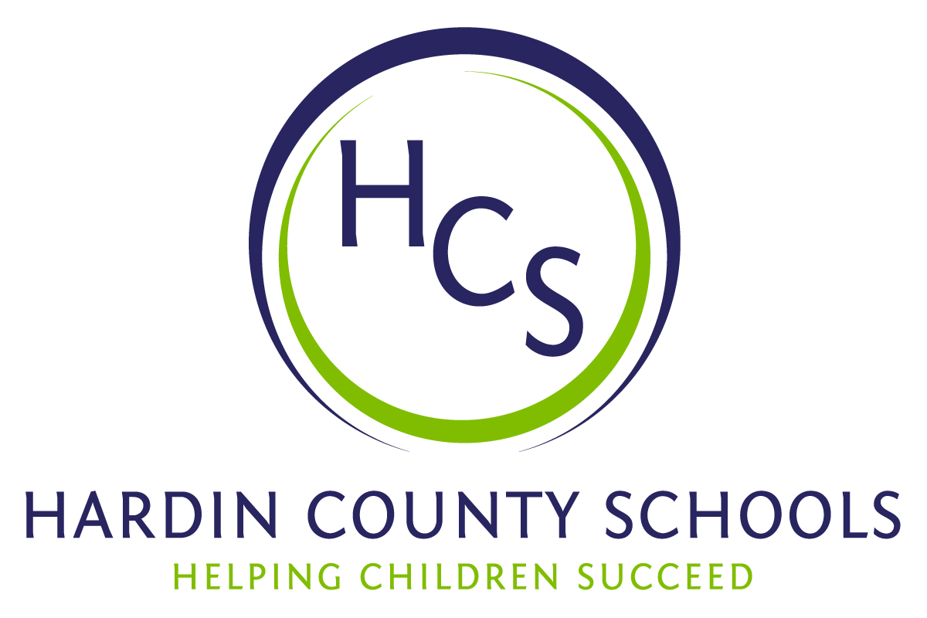
Board of Education
Dawn Johnson, Chair
Ben Sego, Vice Chair
Steve Bland
Mark Casey
Charlie Wise

Chief Academic Officer
Greg Sutton

Chief Operations Officer
John Stith

Teresa Morgan, Superintendent

Resolution of Recognition

WHEREAS, the function of a Board of Education is to strive for excellence in all phases of educational programs, and;

WHEREAS, a major indication of such excellence is awards and honors earned by the students, employees and programs of the school system, and;

WHEREAS, the Hardin County Board of Education deems it fitting and proper that significant awards and honors be recognized by the Board;

BE IT THEREFORE RESOLVED THAT the Hardin County Board of Education, meeting in regular session on May 16, 2024, does hereby recognize the achievements of the following:

- East Hardin Middle School Student Technology Leadership Program (STLP) - 2024 Minds on Innovation Challenge 1st Place: Brayden Bowles, Braxton Hornback, Bentley Banks, Brady Grace

- East Hardin Middle School student Tristan Hardin has made the National Archery in Schools Program (NASP) All-American team.

- James T. Alton Middle School Student Aksh Patel earned first place in the Kentucky Secretary of State’s 2023-2024 Voter Registration Slogan Contest

- West Hardin Middle School Student 7th Grader Isabella Lee earned the state championship in the Kentucky Department of Agriculture’s Seventh Grade Annual Poster Contest.

- West Hardin Middle School Student 6th Grader Louis Walker earned the state championship in the Kentucky Department of Agriculture’s Sixth Grade Annual Poster Contest.

- Lakewood Elementary School Students Lily Caccam, Anabel Yarley - Kentucky All-State Children’s Choir

- James T. Alton Middle School BETA - Noah Dale- 3rd Place – Electronically Enhanced Photo

- James T. Alton Middle School Camp Sandra Day O’Conner Camp Participant - Liam Lentz

- Heartland Elementary School Student Technology Leadership Program - Cameron Dye - 2nd Place Tech Quiz Bowl

- Bluegrass Middle School You Be the Chemist State Champions: Emmett England, Ezra Simon, Hunter Baker, Liam Kleparek

- John Hardin High School State DECA Conference
  - Kaleigh Booth, 1st Place in Apparel and Accessories Marketing
  - Josie Heer, 2nd Place Principals of Hospitality

- John Hardin High School & North Hardin High School SkillsUSA Crime Scene Investigation 2nd Place
  - LeeAnn Kroth (JHHS)
  - Rylee Eikenberry (NHHS)
  - Caitlyn Johnson (NHHS)

Heartland Elementary State BETA State Convention:
- Zoe Martin, Jase Colson, Cameron Dye, & Luke Chism- Beta Quiz Bowl- 2nd Plac
- Archer England- Beta Poetry- 1st Place
- Graysen Wallace- Beta Visual Arts: Jewelry- 2nd Place
- Andrew Netzel- Beta Visual Arts: Recyclable Art-3rd Place
- Andrew Netzel, Ellis Cammack, Huntington Vinson, & Tucker French- Beta Technology-2nd Place
- Cameron Dye- Beta Academic Test: 5th Grade Social Studies- 2nd Place
- Regina De La Rosa Martinez- Beta Academic Test: 4th Grade Spanish- 2nd Place
- Beta Club Project: Apparel Design- 3rd Place
- Beta Club Project: Three-Dimensional Design- 1st Place
- Beta Club Project: Two-Dimensional Design- 3rd Place
- Amelia Ellis, Avery McDonald, Claire Dansby, & Zoe Martin- Beta Musicology- 1st Place
Performing Arts: Large Group Talent- 1st Place
- Sydni McCombs- Beta Visual Arts: Digitally Enhanced Photography-3rd Place
- Helena Dutkanicz- Premier Performer Singer
- Avery McDonald- Premier Performer Singer
- Emma Stinson- Premier Performer Singer

Lakewood Elementary School State BETA Convention:
- Annabel Yarley, first place for onsite painting
- Lily Caccam, first place for onsite drawing
- Leah Rainey, third place in 3D art

Lincoln Trail Elementary School BETA Convention:
- Adi Hardesty, Alyssa Brackett, Paisley Miller, Caleigh Jo Scott - Two Dimensional Design- 1st Place
- Rosalee Lockwood - Premier Performer & Performing Arts - Solo Vocalist 2nd Place

John Hardin High School E-Sports - State Runner-Up:
- Brianne Anderson
- Kris Cannon
- Nathan Dore
- Liam Headstream
- Alex Hurt
- Kyle McCormick,
John Hardin High School Governor’s School for the Arts:
- Harper Taylor
John Hardin High School Governor’s Scholar Program Students:
- Samantha McNichol
- Eunice Olukolajo
Central Hardin High School Governor’s Scholar Students:

- Cade Badstibner
- Lindy Barnes
- Noah Bennett
- Taylor Brackett*
- Owen Coursey*
- Preslee Decker
- Andrew Disselkamp
- Hazel Duckworth*
- Jared Fairbanks
- Preslee Fergerson*
- Breonna Gwinn
- Addilyn Johnson
- Evan Kimberlain*
- Braxton Loeffler
- Emerson McNeilly
- Preston Meredith
- Mattie Miller*
- Samuel Nelson
- Clair Nusbaumer
- Ava Stith
- Juliana Stith
- Mea Tabor
- Jacob Turlington

*GSP alternates

Central Hardin High School Governor’s School for the Arts Students:
- Evelyn Barner - Visual Art
- Addison Barnes - Musical Theatre
- Aiden Perry - Film + Photography
- Harper Scott - Instrumental Music (Woodwinds)
Central Hardin High School Governor’s School for Entrepreneurship Students:
- Noah Bennett
- Elena McNeil
John Hardin High School BETA Convention:
- Lucas Keown Pottery Division II 1st place;
- LeeAnn Knoth Painting Division II 1st place;
- Harper Taylor, Samantha McNichol, Taylor Barno, Brendan Nagle, Mariana Diaz, Kyle McCormick, Izabella Hutchinson, Samara Higgins, Sydney Martin - Performaing Arts Small Group talent 2nd place
- Harper Taylor - Performing Arts Variety Act 3rd Place;
- Digitally Enhanced Photography Division II Anya Carson 2nd Place;
- Neveah Wright - Jewelry Division II 2nd place;
- Abby Carrier, Jada Gray, Serenity Tate, Chase Field, Reed Bischoff, and Ram Danturthi - Robotics Showcase 2nd place
North Hardin High School Family, Career and Community Leaders (FCCLA) State Winners:
- Lilliana Page- 1st place- Say Yes to FCS
- Amelia Rose- 2nd place- Public Policy Advocate
- Sara Beth Anderson- Food Innovations
- Jaden Hayes- Repurpose and Redesign
- The NHHS chapter received a Gold Honor Roll distinction.
North Hardin High School Governor’s Scholar Program Students:
- Gabriela Palomo
- Reese Thompson
- Nicholas Hake (Alternate)
North Middle School BETA
- Songfest -3rd place
- Charlie McMillen 3rd place- On-Site Drawing
East Hardin Middle School BETA State Convention winners:
- Case Preston, Justin Johnson, Ava Young, & Jack Melloan - 1st Place - Beta Quiz Bowl
- Jude Tabor - 1st Place Beta Academic test Language Arts
- Jack Melloan - 2nd Place Beta Academic test Math
- Justin Johnson - 1st Place Beta Academic test Science
- Lucas Blevins - 1st Place Beta Academic test Math
- Cooper Barnes - 2nd Place Beta Spelling Bee
- Maeve Crady - 3rd Place Beta Academic Test LA
- Kendra Livingood - 3rd Place Beta Academic Test LA
- Piper Middeler - 3rd Place Beta Academic Test Math
- Case Preston - 3rd Place Beta Academic Test SS
- EHMS - Group Talent- FIRST PLACE
- EHMS – Songfest – Second Place
- Lucy Melloan, Jack Meloan, John Melloan- 1st Place, Solo duo trio
- Lilia Kimberlain- 1st Place Onsite Painting & - 1st Place Painting
- J'Li Lyons- 1st Place- Pottery
- Halyn Kramer- 1st Place- Poetry
- Reagan Kaster- 1st Place- Quilling
- Konnor Brown, Addison Garland, Millie Corley, Cwynn Yates, Leah Anderson- 3rd Place Digital Portfolio
- Aiden Rios-Rodriguez- 3rd PLace Hand Drawn Anime'
- Hank Waddell, Luke Steucker, Ben Stinnett, Carina Lucas- 3rd Place, Trading Pins
- Lucas Kaster, Reagan Kaster, Emma Marcum- 3rd Place, Scrapbook
- Reagan Kaster, Chuma Nnorom, Laikyn Yates, Rhett Edlin, Peyton Noyes- 3rd place Musicology
- Lucy Melloan- Premier Performer
- Lauren Forbis- First Place - 6th grade essay competition, "Agriculture for a Better Kentucky"
East Hardin Middle School Eighth-Grade Choir Championships Music in the Parks:
- First Place – Middle/Junior High AA Division
- Grand Champion for all Divisions of Middle/Junior High
- Rhett Edlin - Music in the Parks Multi-State Division Outstanding Jr High Vocal Soloist

The Board extends its congratulations to this student for the recognition he has earned for himself and Hardin County Schools.

