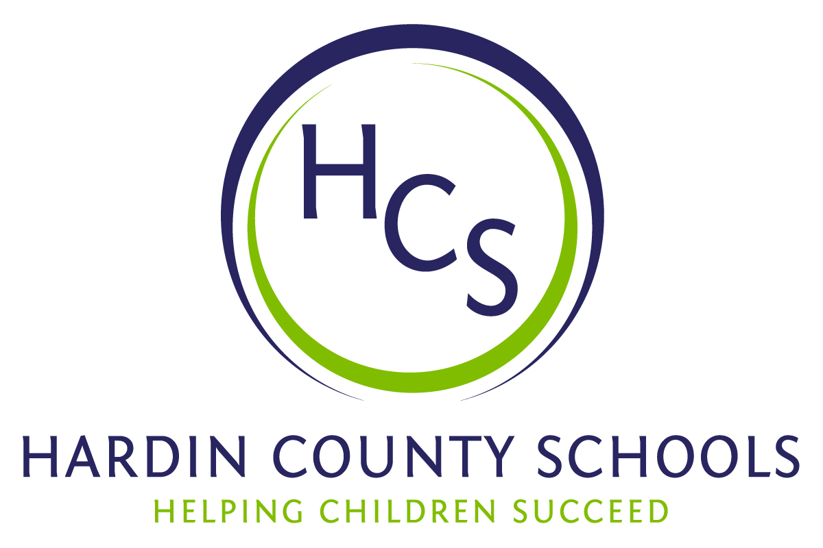
Board of Education
Dawn Johnson, Chair
Ben Sego, Vice Chair
Steve Bland
Mark Casey
Charlie Wise

Chief Academic Officer
Greg Sutton
Chief Operations Officer
John Stith

Teresa Morgan, Superintendent

Resolution of Recognition
#HCSBetterTogether Award

WHEREAS, the function of a Board of Education is to strive for excellence in all phases of educational programs, and;

WHEREAS, the Hardin County Board of Education deems it fitting and proper that significant awards and honors be recognized by the Board, and;

WHEREAS, the Hardin County Board of Education believes in work ethic and the ability of students, staff and community members who dedicate themselves totally to the education of our next generation of leaders, and;

WHEREAS, the district’s theme for the 2023-24 school year is #HCSBetterTogether and the Hardin County Board of Education believes in these characteristics so greatly that it will recognize HCS students & staff and Hardin County community members at its regularly scheduled meeting each month during the school year with the #HCSBetterTogether Award;

BE IT THEREFORE RESOLVED THAT the Hardin County Board of Education, in a regular meeting on May 16, 2024, does hereby recognize the following for earning the #HCSBetterTogether Award for May 2024:

- Samantha McNichol, a John Hardin High School junior, is successful in all of her endeavors. She is a member of the JHHS Tennis team. She recently performed in “Legally Blonde” and created several of the costumes and altered others. She is a member of the John Hardin HS Academic Team and will participate in the Governor’s Scholar program this summer. She also owns and operates a small baking business called Sweets by Sam.
- Richard Rowland is a social studies teacher at James T. Alton Middle School. He also works tirelessly to spread the good news about JTA, serving as the school’s public relations coordinator. Mr. Rowland has forged relationships statewide to ensure students are competing at the highest levels. JTA Principal Danielle Cassady says that Mr. Rowland is humble and works hard to advocate for others without seeking any personal accolades. He has coordinated various initiatives that highlight student accomplishments. He instills a spirit of service in students. Through project-based learning initiatives, he has empowered students to organize their own service projects, resulting in impactful contributions to our community. Whether it's the donation of over 3000 items to the Brown Cancer Center or the delivery of Christmas cards to local nursing homes, Mr. Rowland actively cultivates a sense of empathy and compassion among students. One of Mr. Rowland's most notable contributions is his work with the Peer Buddies Program. It pairs special needs students with their peers for mentorship and friendship. By fostering inclusive relationships, Mr. Rowland ensures that every student feels valued and supported within our school community.
- Carol George is the Athletic Training Program Manager at Baptist Health Hardin. While Carol is an advocate and works to ensure that students are healthy on the field of completion, she is also dedicated to the HCS Work Ethic Work Ethic Certification Program. The program consists of student applications for the certification and culminates in students visiting with community leaders in a real interview. After the interview is complete, the interviewer gives the students extremely valuable feedback to use in the future. Carol has interviewed hundreds – maybe thousands – of students for Work Ethic Certification. She has participated in the program since Day One. Her dedication, loyalty, and input are appreciated and will always be valued.

