THIS IS A DECISION PAPER

TO: HARDIN COUNTY BOARD OF EDUCATION

FROM: Teresa Morgan, Superintendent

DATE: May 16, 2024

SUBJECT: APPROVAL OF NEW HIGHLAND ELEMENTARY ROOF REPAIR

ISSUE:
The roof at NHES has several leaks.

FACTS:

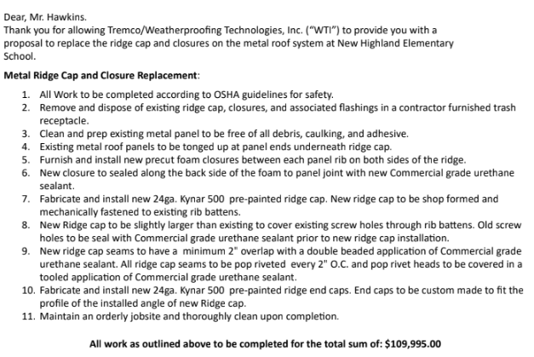

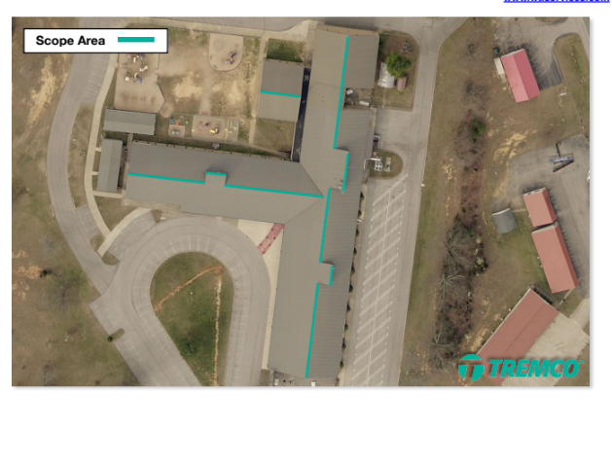

RECOMMENDATION
I RECOMMEND THE HARDIN COUNTY BOARD OF EDUCATION APPROVE THE NHES ROOF REPAIR WITH TREMCO.

RECOMMENDED MOTION
I MOVE THE HARDIN COUNTY BOARD OF EDUCATION APPROVE THE NHES ROOF REPAIR WITH TREMCO.

