THIS IS A DECISION PAPER

TO: HARDIN COUNTY BOARD OF EDUCATION

FROM: Teresa Morgan, Superintendent

DATE: May 16, 2024

SUBJECT: APPROVE GUARANTEED ENERGY SAVINGS CONTRACT AND CORRESPONDING BG 1 WITH TRANE

ISSUE: The Board needs to approve the revised BG 1 and contract documents for the NHE/Lakewood HVAC, District Lightening, and Solar Guaranteed Energy Savings Project.

FACTS
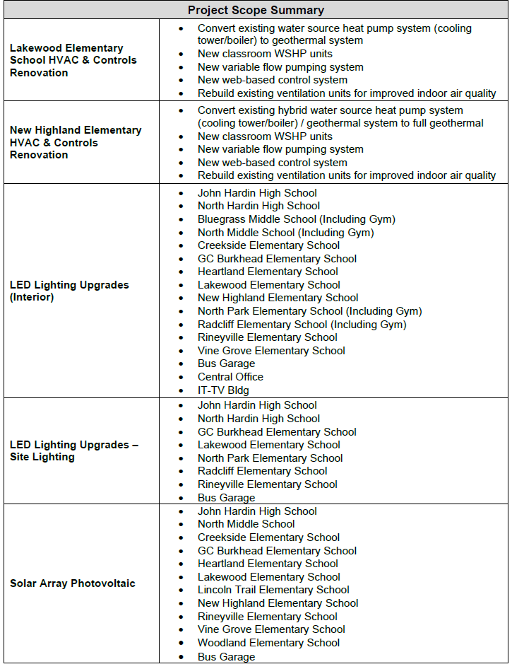

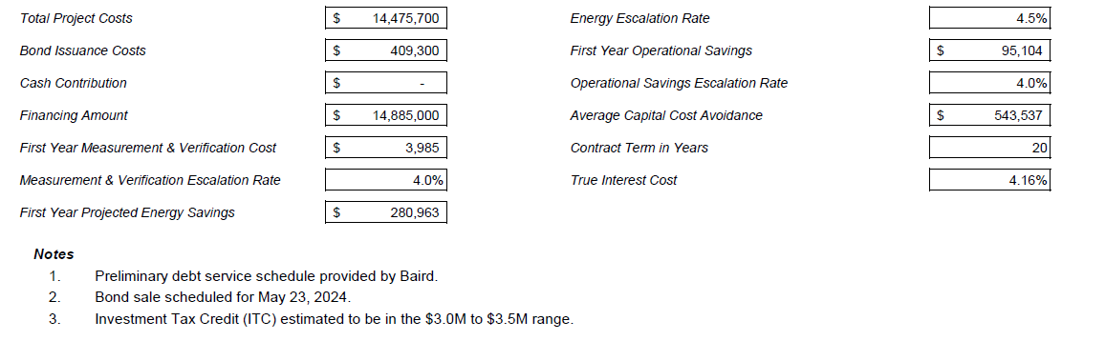

*See attached docs

RECOMMENDATION
I RECOMMEND THE BOARD approve the revised BG1 and contract dOCUMENTs for the guaranteed energy savings project.

RECOMMENDED MOTION

I MOVE THE BOARD approve the revised BG 1 and contract DOCUMENTS FOR the guaranteed energy savings project.

