THIS IS A DECISION PAPER

TO: HARDIN COUNTY BOARD OF EDUCATION

FROM: Teresa Morgan, Superintendent

DATE: May 16, 2024

SUBJECT: APPROVAL OF PURCHASE AGREEMENT REESOR PROPERTY

ISSUE:
Due to the anticipated growth in the county, the Hardin County Board of Education has been evaluating potential sites suitable for a future school campus. After reviewing a number of properties, the board is ready to finalize a purchase agreement for 100 acres on the northeast side of Elizabethtown for the purpose of procuring a future site to build a school campus. There are still a number of investigations, regulations, and permissions that the board will need to secure to purchase the property.

FACTS:

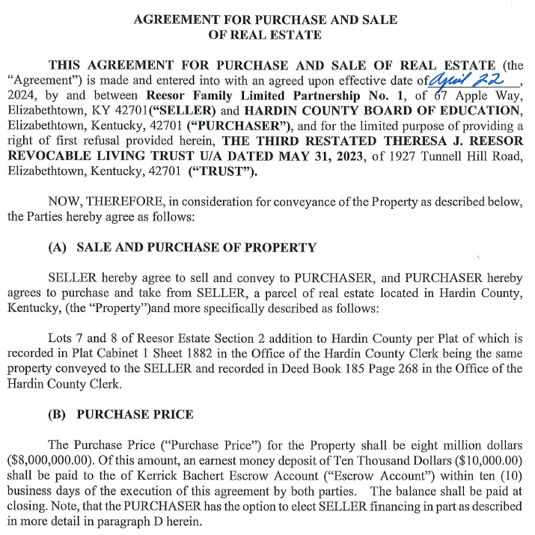

RECOMMENDATION
I RECOMMEND THE BOARD APPROVE the purchase agreement with the reEsor family Partnership Number 1.

RECOMMENDED MOTION
I MOVE THE BOARD the purchase agreement with the reEsor family partnership number 1.

