THIS IS A DECISION PAPER

TO: HARDIN COUNTY BOARD OF EDUCATION

FROM: Teresa Morgan, Superintendent

DATE: May 16, 2024

SUBJECT: APPROVAL OF CHANGE ORDERS 110-111 FOR THE CHHS PHASE 1 CONSTRUCTION PROJECT

ISSUE:
Change Order 110 is a debit of $ 4,034.18 and is for a temporary sidewalk to allow students to move from the old portion of the building to the new square footage. Change Order 111 is a credit of $ 7,500 and is for a wireless bleacher connection Irwin Bleacher did not install.

FACTS:

CO 110

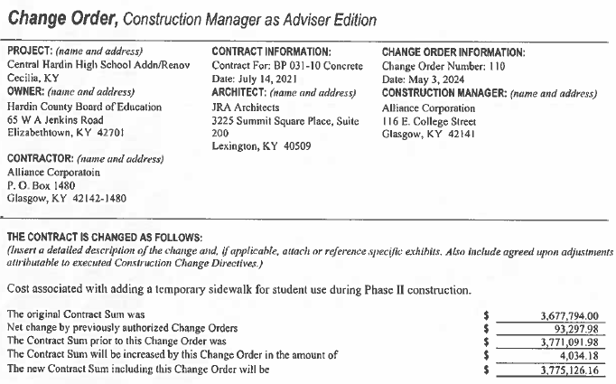

CO 111

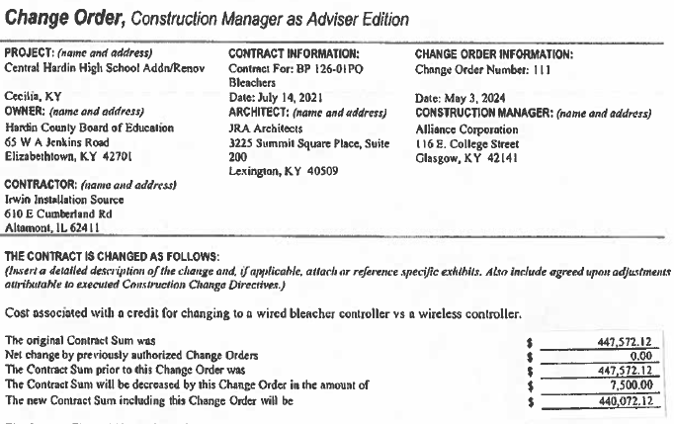

RECOMMENDATION
I RECOMMEND THE BOARD APPROVE CHANGE ORDERs 110-111 for the CHHS Phase 1 Construction project.

RECOMMENDED MOTION
I MOVE THE BOARD APPROVE CHANGE ORDERs 110-111 for the CHHS Phase 1 Construction project.

