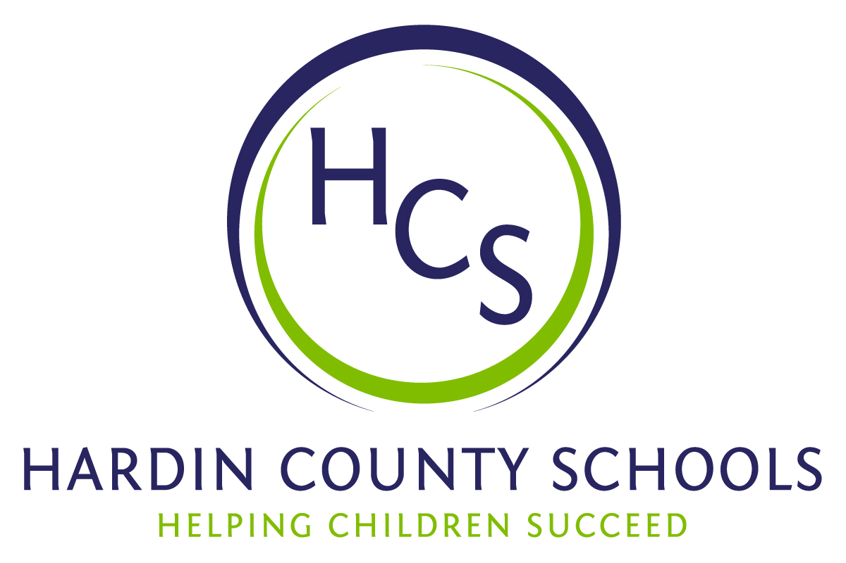
Board of Education
Dawn Johnson, Chair
Ben Sego, Vice Chair
Steve Bland
Mark Casey
Charlie Wise

Chief Academic Officer
Greg Sutton
Chief Operations Officer
John Stith

Teresa Morgan, Superintendent

Resolution of Recognition
#HCSBetterTogether Award

WHEREAS, the function of a Board of Education is to strive for excellence in all phases of educational programs, and;

WHEREAS, the Hardin County Board of Education deems it fitting and proper that significant awards and honors be recognized by the Board, and;

WHEREAS, the Hardin County Board of Education believes in work ethic and the ability of students, staff and community members who dedicate themselves totally to the education of our next generation of leaders, and;

WHEREAS, the district’s theme for the 2023-24 school year is #HCSBetterTogether and the Hardin County Board of Education believes in these characteristics so greatly that it will recognize HCS students & staff and Hardin County community members at its regularly scheduled meeting each month during the school year with the #HCSBetterTogether Award;

BE IT THEREFORE RESOLVED THAT the Hardin County Board of Education, in a regular meeting on April 18, 2024, does hereby recognize the following for earning the #HCSBetterTogether Award for April 2024:

- Makayla Mosher, a Central Hardin High School senior, is a wonderful student who excels in and out of the classroom. She works at the Hardin County Clerk’s Office. In a recent feature in The News-Enterprise, Deputy Clerk Ashley McMurtry said, “Makayla is no ordinary high school student. The amount of trust and responsibility we can give her goes way beyond a normal student job. Makayla was tasked with digitizing older records. The goal was for her to get two to three books scanned each week. Through her ability to multitask and be efficient, she scanned three books on her first day.”

She is also deeply involved with the Central Hardin FFA. She serves as secretary volunteers for community projects and presents team projects at regional competitions. She will attend either Murray State University or ECTC to pursue a career working with animals.

- Sara Ice is a fourth-grade teacher at Lakewood Elementary School. She has worked her way from being an instructional assistant in a special needs classroom years ago to a phenomenal 4th-grade teacher. Ms. Ice is always one of the last to leave the school and the first to arrive. She prepares detailed and outside-of-the-box experiences for her students. She has helped lead things such as planting a school-wide pumpkin patch, leading nature clubs and hikes, making corn husk dolls, teaching students to grind their own cornmeal, and make pumpkin muffins from scratch. Ms. Ice possesses authentic love and care for her students and co-workers. It is shown through the extra time she spends reaching out to families and challenging her students to do acts of kindness for those who may get overlooked.

- Pastor Marcus Dixon and the Phi Beta Sigma Fraternity provide tremendous support to Hardin County Schools. The fraternity and a social sorority – Zeta Phi Beta - to North Hardin High School as mentoring groups. Phi Beta Sigma works feverishly in the community to assist the North Hardin Youth Service Center with donations of goods, services, and money. North Hardin Youth Service Center Coordinator Leslie Hall notes three separate situations where items were needed for students. The needs were met after one email to the Phi Beta Sigmas.

The Phi Beta Sigma and the Zeta Phi Beta sorority earned the 2023 FRYSCKy Bridges Over Barriers Award for their mentoring work.

Phi Beta Sigma members have donated lots of dollars to the HCS Family Stability Program. Their work has helped many children succeed in and out of the classroom.

