THIS IS A DECISION PAPER:
TO: Members of the Hardin County Board of Education
FROM: Teresa Morgan, Superintendent
DATE: April 18, 2024
SUBJECT: Quotes for Student Accident Insurance/Roberts Insurance & Investments
DISCUSSION:
HCS has purchased Student Accident Insurance for all students for the past several years with rates are as follows: 19-20 for $67,868, 20-21 for $67,797.20, 22-23 for $66,200.20, and 23-24 for $73,731.20. This year Robert’s Insurance & Investments rate, under plan 4B with Berkley Accident and Health/Zurich American (Catastrophic Only) Insurance is unchanged at $73,731.20 same as last year
See Roberts bid info below:
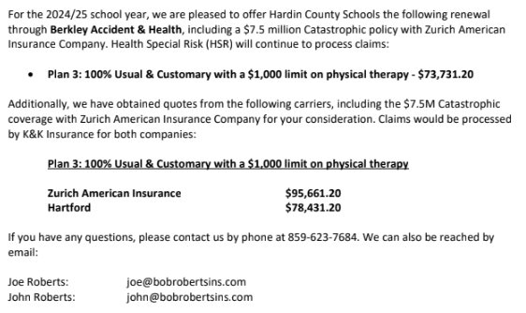

RECOMMENDATION:
I recommend the Members of the Hardin County Board of Education renew our student accident insurance plan with Roberts Insurance for the 24-25 School year by accepting the Berkley Accident and Health bid of $73,731.20.
RECOMMENDED MOTION

I Move the Hardin County Board of Education renew our student accident insurance plan with Roberts Insurance for the 24-25 School year by accepting the Berkley Accident and Health bid of $73,731.20.

