THIS IS A DECISION PAPER

TO: HARDIN COUNTY BOARD OF EDUCATION

FROM: Teresa Morgan, Superintendent

DATE: April 18, 2024

SUBJECT: APPROVAL OF CHANGE ORDER 1 FOR THE WOODLAND HVAC CONSTRUCTION PROJECT

ISSUE:
Change Order 1 is a credit of $ 188,306 and is for unused well casing allowance and costs associated with damage to the roof trusses.

FACTS:

CO 1
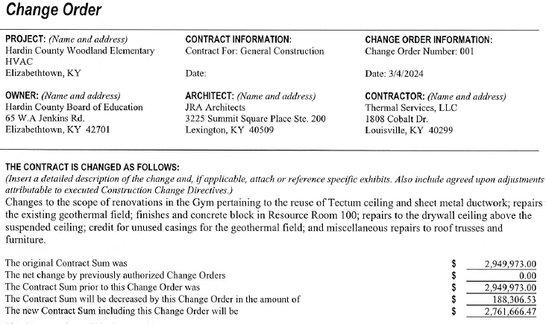

RECOMMENDATION
I RECOMMEND THE BOARD APPROVE CHANGE ORDER 1 for the Woodland HVAC Construction project.

RECOMMENDED MOTION
I MOVE THE BOARD APPROVE CHANGE ORDER 1 for the woodland HVAC Construction project.

