THIS IS A DECISION PAPER

TO: HARDIN COUNTY BOARD OF EDUCATION

FROM: Teresa Morgan, Superintendent

DATE: April 18, 2024

SUBJECT: APPROVAL OF CHANGE ORDERS 104-109 FOR THE CHHS PHASE 1 CONSTRUCTION PROJECT

ISSUE:
Change Orders 104-107 are debits of $ 9,906.99, $2,052.77, $400.51, and $ 6,121.56 totaling $18,481.83. These are costs associated with the windows in the big gym. Change Order 108 is a credit of $ 20,994.77 and reverses CO 80 related to the big gym windows. Change Order 109 is a debit of $ 3,228 and is for additional water/air testing of the widow and curtain wall systems.

FACTS:

CO 104

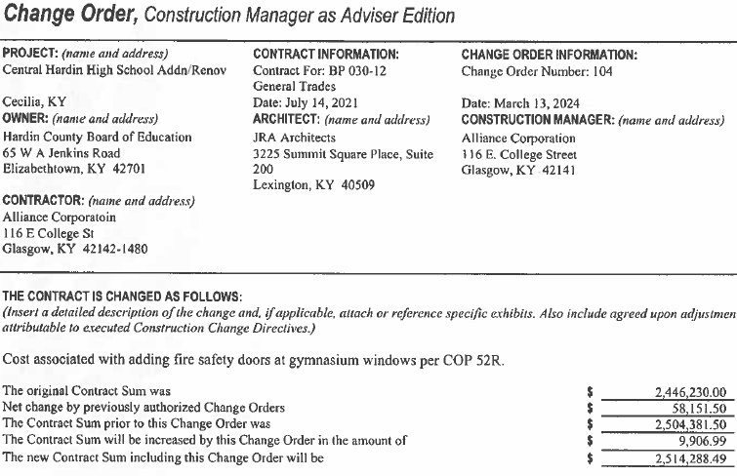

CO 105

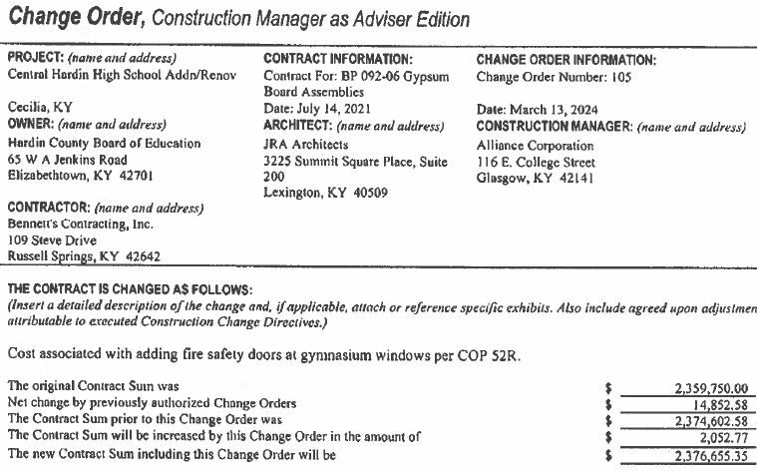

CO 106

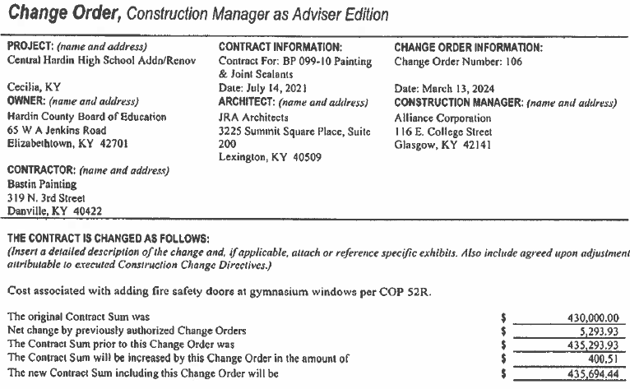

CO 107

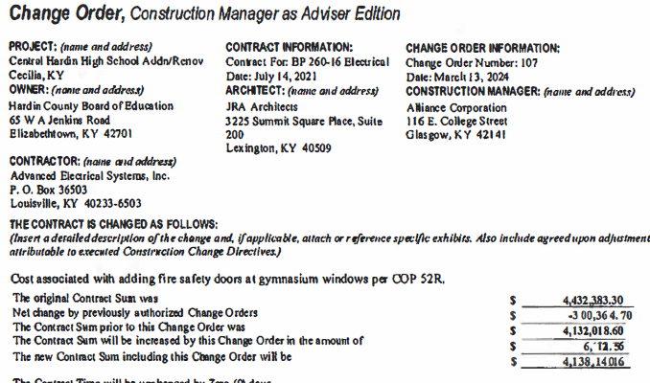

CO 108
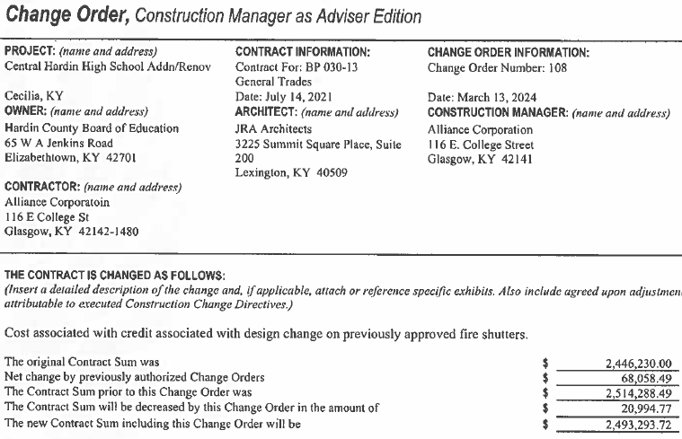

CO 109

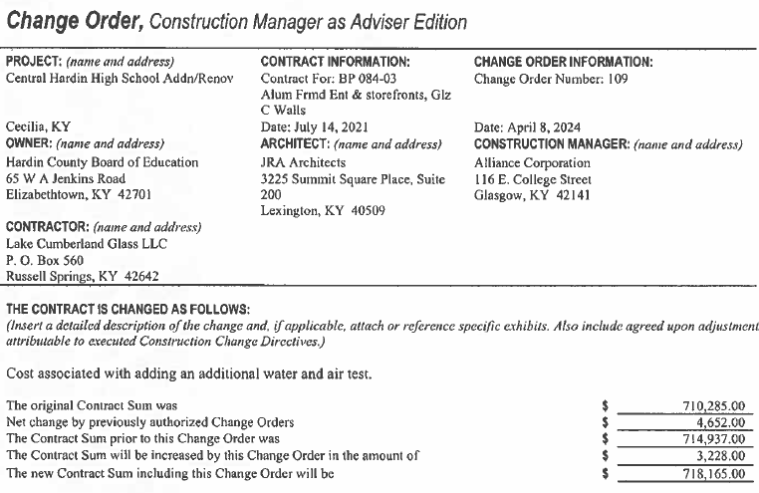

RECOMMENDATION
I RECOMMEND THE BOARD APPROVE CHANGE ORDERs 104-109 for the CHHS Phase 1 Construction project.

RECOMMENDED MOTION
I MOVE THE BOARD APPROVE CHANGE ORDERs 104-109 for the CHHS Phase 1 Construction project.

