THIS IS AN INFORMATION PAPER:
TO: Members of the Hardin County Board of Education
FROM: Teresa Morgan, Superintendent
DATE: April 18, 2024
SUBJECT: PAC Theatrical Lights and Control Board
DISCUSSION:
Bart Lovins, PAC Director, reports that the theatrical lights are at the end of life and are starting to fail. In addition, the control board that operates them is having similar issues. He has worked with maintenance to get quotes to replace them. See attached.
VLS
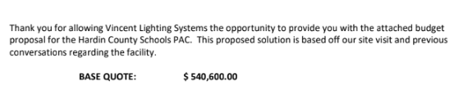
LHI
