THIS IS A DECISION PAPER

TO: HARDIN COUNTY BOARD OF EDUCATION

FROM: Teresa morgan, Superintendent

DATE: March 21, 2024

SUBJECT: APPROVAL OF CHANGE ORDERS 101-103 FOR THE CHHS PHASE 1 CONSTRUCTION PROJECT

ISSUE:
Change Orders 101-103 are debits of $ 2,966.14, $24,818, and $ 2,241.40 totaling $30,025.54. They are costs associated with spraying insulating foam on the exterior side of the kitchen so all interior work can be completed in Phase 1.

FACTS:

CO 101

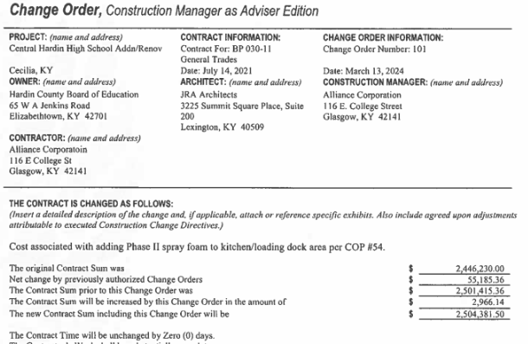

CO 102
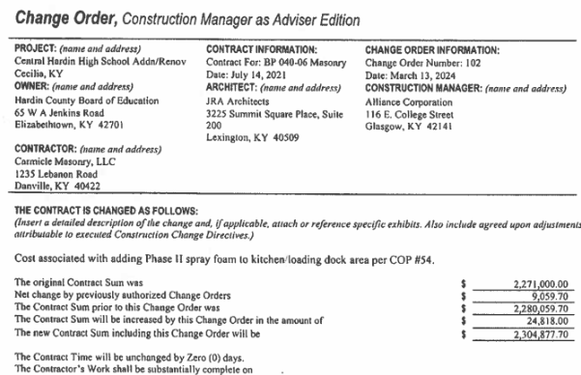

CO 103

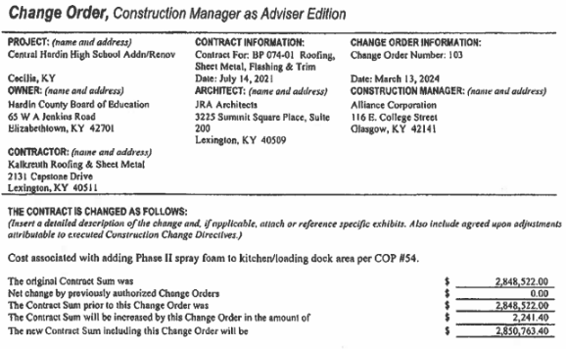

CO 100

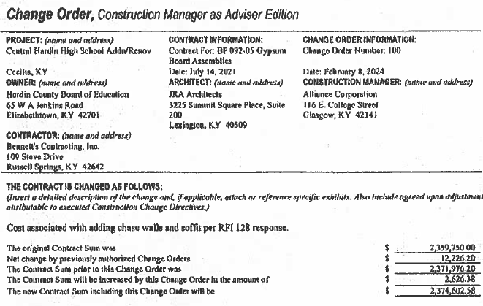

RECOMMENDATION
I RECOMMEND THE BOARD APPROVE CHANGE ORDERs 101-103 for the CHHS Phase 1 Construction project.

RECOMMENDED MOTION
I MOVE THE HARDIN COUNTY BOARD OF EDUCATION APPROVE CHANGE ORDERs 101-103 for the CHHS Phase 1 Construction project.

