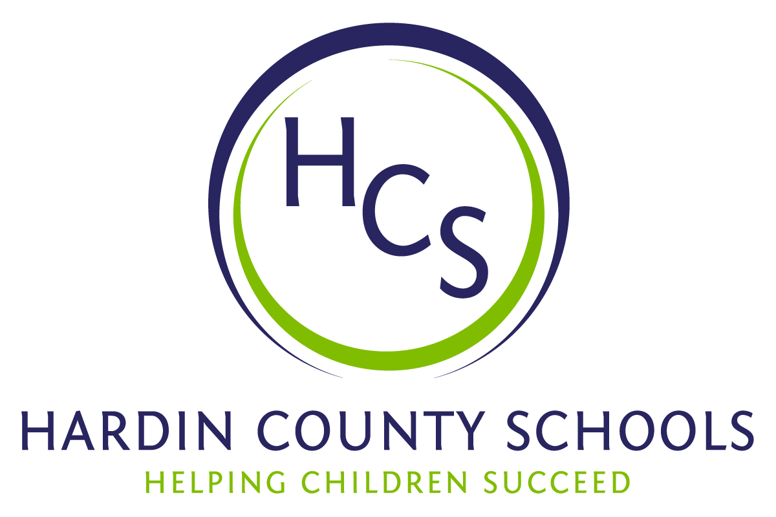
Board of Education
Dawn Johnson, Chair
Ben Sego, Vice Chair
Steve Bland
Mark Casey
Charlie Wise

Chief Academic Officer
Greg Sutton

Chief Operations Officer
John Stith

Teresa Morgan, Superintendent

Resolution of Recognition

WHEREAS, the function of a Board of Education is to strive for excellence in all phases of educational programs, and;

WHEREAS, a major indication of such excellence is awards and honors earned by the students, employees, and programs of the school system, and;

WHEREAS, the Hardin County Board of Education deems it fitting and proper that significant awards and honors be recognized by the Board;

BE IT THEREFORE RESOLVED THAT the Hardin County Board of Education, meeting in regular session on March 21, 2024, does hereby recognize the achievements of the following:

- Christian Delos Santos, a John Hardin High School junior, earned a state championship in the 113-pound weight class at the Kentucky High School Athletic Association Boys Wrestling State Championships.

- Naiya Delos Santos, a Bluegrass Middle School 8th grader, earned third place in the 100-pound weight class at the Kentucky High School Athletics Association Girls Wrestling State Championships.

- Kayleigh Rice, a John Hardin High School junior, earned the 2A state championship in the Girls Shot Put Event with a mark of 34’9.5” at the Kentucky High School Athletic Association Indoor Track and Field Championships.

- Isaac Johnson, a James T. Alton Middle School 8th grader, earned a spot in the Kentucky Band Organization’s All-State Middle School Band (percussion).

- Thomas Urbahns, an East Hardin Middle School 8th grader, earned a spot in the Kentucky Music Educators Association All-State Middle School Band (bass clarinet).

- Case Preston, an East Hardin Middle School 8th grader, earned a state championship for Social Studies at the Kentucky Governor’s Cup Academic Meet Championships.

- The following East Hardin Middle School students earned the state championship in Community Problem Solving (with an education project on Alpha Gal Syndrome and its prevention) at the Kentucky Governor’s Cup Academic Meet Championships:

- Brylee Blankenship (8th grade)
- Leah Anderson (6th grade)
- Millie Corley (6th grade)
- Hanna Martin Canto (6th grade)
- Kadyn Shive (6th grade)

- The following West Hardin Middle School students earned a spot in the Kentucky Music Educators Association All-State Middle School Band:

- Abigail Shader – flute (8th grader)
- Josie Eskridge – clarinet (8th grader)
- Maddie Brady – trumpet (8th grader)
- Lesly Newman Garcia – mallet (8th grader)

- The following HCS high school students take classes in the Culinary Pathway at the HCS Early College and Career Center. They earned first and second place at the Kentucky ProStart Championships. It’s a culinary competition organized by the state and National Restaurant Association Educational Foundation. This is the third consecutive year that HCS students have earned the state championship.

State Champions:
- Kevin Haddox
- Eddie Goldsmith
- Brianna Jones
- Kiara Feliciano
- Alonah Lamkin

State Runners-Up:
- Katie Roth
- Jamie Neal
- Jason Scott
- Sydney Manful
- Daniel Davidofsky

- The following John Hardin High School students earned first and second place at the Kentucky JROTC Air Rifle Championships. The Junior Varsity Sporter Team earned the state championship. The Varsity Sporter Air Rifle Team earned the State runner-up honors.

State Champions:
- Madison Moore
- Riley Quinn
- Talitha Diaz
- Abigail Salm

State Runners-Up:
- Philip Bischoff
- Armen Yum
- Taylor Quinn
- Caleb Caudill

- The Central Hardin High School JROTC Drill Team was invited to compete in the 2024 Army JROTC National Drill competition by the 7th ROTC Brigade JROTC Director at Fort Knox.

  - Brock Angell
  - Kayden Banet
  - Lily Callahan
  - Robert Compton
  - Savannah Davis
  - Landen Fisher
  - Jaden Gavin
  - Olivia Johnston
  - Cooper Lewis
  - Lily McGlone
  - Gavin Nalley
  - Micah Papoutsis
  - Charles “Reece” Rhinehart
  - Shaun Ruddle
  - Mason Sauerbrey
  - James Schall
  - Colton Stillwell
  - Jacob Turlington
  - Ethan Williams

- Jason Neagle, Engineering Pathway instructor at the Hardin County Schools Early College and Career Center, was recently presented with the Lifetime Achievement Award by the Kentucky VEX Robotics Coaches Association for his service and dedication to VEX Robotics. Mr. Neagle’s teams have earned countless regional, state, national, and international awards.

The Board extends its congratulations to these students and staff for the recognition they have earned for themselves and Hardin County Schools.

