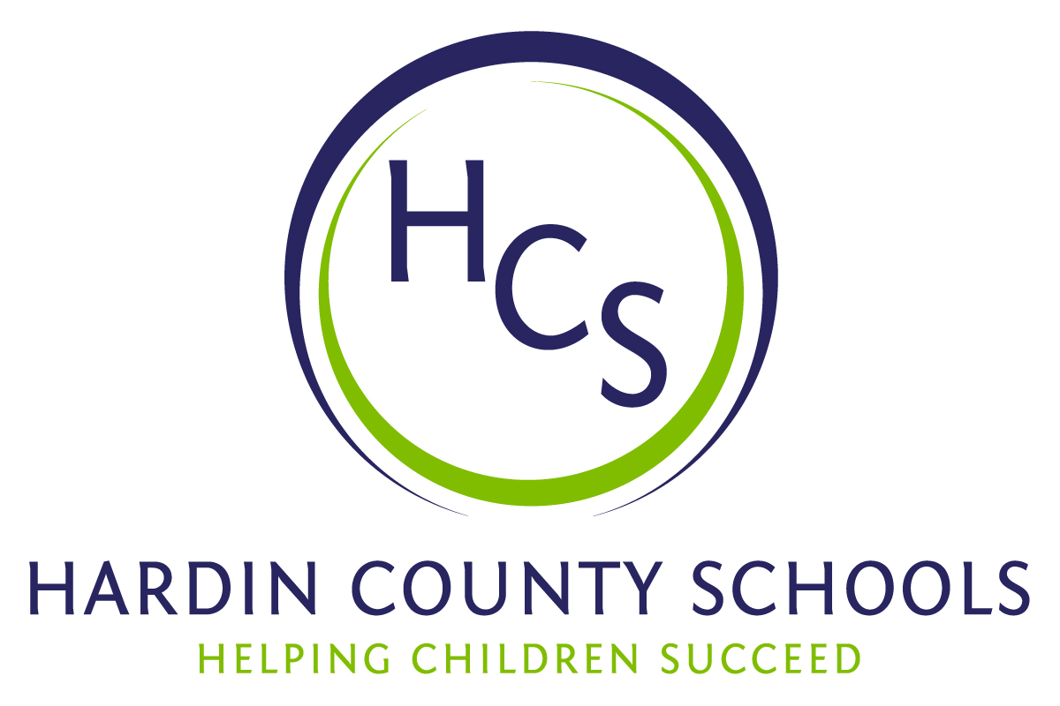
Board of Education
Dawn Johnson, Chair
Ben Sego, Vice Chair
Steve Bland
Mark Casey
Charlie Wise

Chief Academic Officer
Greg Sutton
Chief Operations Officer
John Stith

Teresa Morgan, Superintendent

Resolution of Recognition
#HCSBetterTogether Award

WHEREAS, the function of a Board of Education is to strive for excellence in all phases of educational programs, and;

WHEREAS, the Hardin County Board of Education deems it fitting and proper that significant awards and honors be recognized by the Board, and;

WHEREAS, the Hardin County Board of Education believes in work ethic and the ability of students, staff, and community members who dedicate themselves totally to the education of our next generation of leaders, and;

WHEREAS, the district’s theme for the 2023-24 school year is #HCSBetterTogether and the Hardin County Board of Education believes in these characteristics so greatly that it will recognize HCS students & staff and Hardin County community members at its regularly scheduled meeting each month during the school year with the #HCSBetterTogether Award;

BE IT THEREFORE RESOLVED THAT the Hardin County Board of Education, in a regular meeting on March 21, 2024, does hereby recognize the following for earning the #HCSBetterTogether Award for March 2024:

- Several James T. Alton Middle School students organized a care package drive for Brown Cancer Center patients. They collected more than 3,000 items that they also organized and packaged for the patients while receiving treatment. These students are in Mr. Richard Rowland’s social studies class. They were motivated to do so after seeing the battle of recovery by Kentucky Lt. Governor Jacqueline Coleman.

They called the effort “Coleman’s Mission.” When they delivered the items to the Brown Cancer Center a few weeks ago, Lt. Governor Coleman gave the students a surprise visit and thanked them for their hard work and compassion.

After posting pictures and video of the delivery on the district's social media channels, a family member of a Brown Cancer Center patient shared on the post that their loved one had received one of the care packages and was thrilled to know that the JTA students shared their love and compassion for others.

HCS also wants to thank Deputy Tim Thomas and Deputy Ronnie Crim from the Hardin County Sheriff’s Office for taking the boxes of items to Louisville in cruisers because they were too big and awkward to ride on a school bus.

The students are:

- Natalee Lange
- Kailey Grant
- Alexus New
- EllaNiegh Maupin
- Kiley Wells
- Marius Langley
- Clara Waits
- Brooklynn Kastner
- Madeline Knapp
- Lillian Pollock
- Izzy Dale
- Sofia Jones
- Chase Eisenman
- Jace Main
- Ella Nettles
- Elliot Cancel
- Colby Flickenger
- Liam McIntyre
- Carl Simpson
- Joey Sena
- Landon Meyers
- Joslynn Spellings
- Josie Kuster
- Delonte Howard

- The James T. Alton Child Nutrition Team was the largest contributor to Coleman’s Mission, the school’s care package drive for Brown Cancer Center patients. Nearly 1,100 of the 3,000-plus items collected came from the JTA Child Nutrition team. Their hard work, dedication, and generosity thankfully increased the load of donations. The team is comprised of:

- Kollette Harris, Manager
- Barbra Loop
- Pam McCammon
- Mary Harris
- Amanda Ray
- Larry Moon
- Joyce Ruphard
- Danny Emmons is an exemplary music service representative from Conrad Music Service. His dedication to serving the musical needs of Hardin County Schools spans over five decades, beginning in the mid-1970s. Throughout his tenure, Mr. Emmons has been a steadfast supporter of music education. His impact extends beyond mere service calls; his dedication to our student's success is unparalleled. Mr. Emmons goes above and beyond to ensure that our students have the tools they need to succeed. From providing instruments when students begin their musical journey to spending hours each week repairing instruments in our schools, his selfless actions have provided countless opportunities for students and band programs throughout the area. With gratitude for his 50+ years of service, Danny Emmons exemplifies the spirit of music education and has truly been a cornerstone of our schools' musical success.

