THIS IS A DECISION PAPER

TO: HARDIN COUNTY BOARD OF EDUCATION

FROM: Teresa Morgan, Superintendent

DATE: March 21, 2024

SUBJECT: APPROVE REVISED BG 1 FOR THE CHHS ATHLETIC TURF PROJECT

ISSUE: The Board needs to approve the revised BG 1 documents for the CHHS athletic turf project.

FACTS
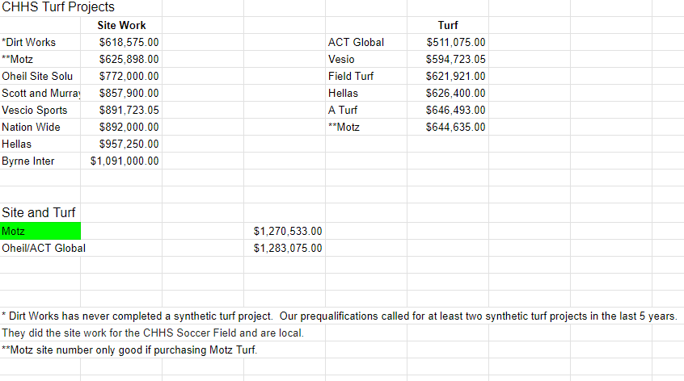

*See attached BG 1

RECOMMENDATION
I RECOMMEND THE BOARD approve the revised BG1 dOCUMENT for the CHHS athletic Turf project as recommended by JRA

RECOMMENDED MOTION

I MOVE THE BOARD approve the revised BG 1 DOCUMENTs FOR the Chhs athletic turf project as recommended by JRA.

