THIS IS A DECISION PAPER

TO: HARDIN COUNTY BOARD OF EDUCATION

FROM: Teresa Morgan, Superintendent

DATE: March 1, 2024

SUBJECT: APPROVE SITE BID AND TURF PRICING FOR THE CHHS SYNTHETIC TURF PROJECT

ISSUE: The Board needs to approve the bid for the CHHS synthetic turf project.

FACTS
As the board is working to upgrade the athletic complex at CHHS, we received the following quotes to resurface the football field on the CHHS campus:

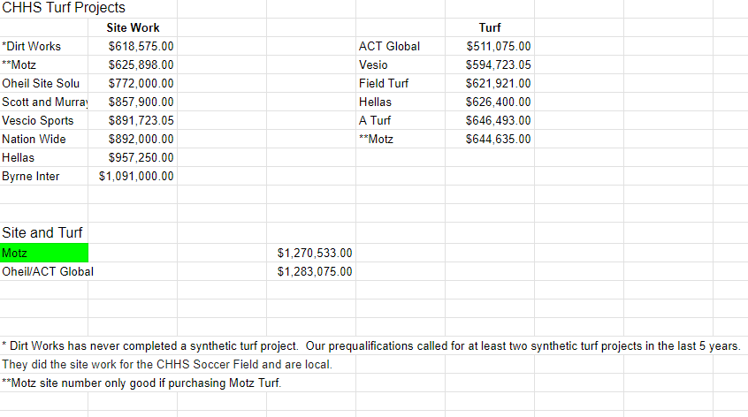
*See JRA’s recommendation

RECOMMENDATION
I RECOMMEND THE BOARD approve the Motz site bid and Motz COOPERATIVE TURF quote for the CHHS synthetic turf project.

RECOMMENDED MOTION

I MOVE THE BOARD approve the site bid and Motz COOPERATIVE TURF quote as recommended by JRA for the CHHS synthetic turf project.

