THIS IS A DECISION PAPER:
TO: Members of the Hardin County Board of Education
FROM: Teresa Morgan, Superintendent
DATE: February 12, 2024
SUBJECT: Pre-Order HVAC Equipment Guaranteed Energy Project
DISCUSSION:
To ensure we have the HVAC equipment on hand to complete the guaranteed energy savings project this summer, Trane is asking that we pre-order ninety-two heat pumps.
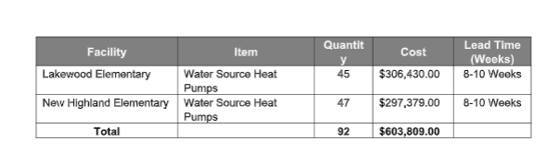
*See attached letter from Trane

RECOMMENDATION
I RECOMMEND THE BOARD APPROVE the pre-order for 92 heat pumps for the guaranteed energy.

RECOMMENDED MOTION
I MOVE THE BOARD APPROVE pre-order for 92 heat pumps for the guaranteed energy.

