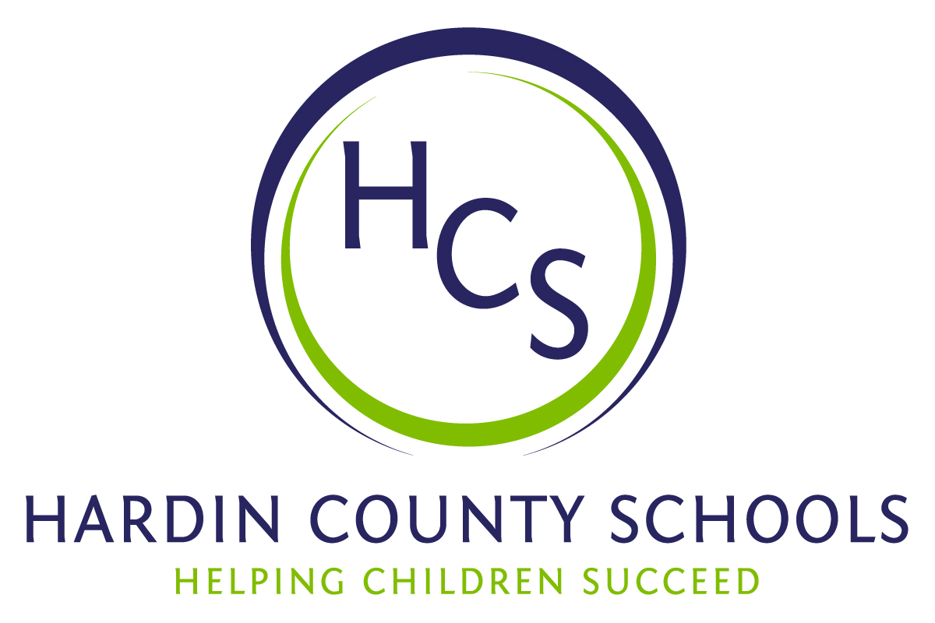
Board of Education
Dawn Johnson, Chair
Ben Sego, Vice Chair
Steve Bland
Mark Casey
Charlie Wise

Chief Academic Officer
Greg Sutton

Chief Operations Officer
John Stith

Teresa Morgan, Superintendent

Resolution of Recognition

WHEREAS, the function of a Board of Education is to strive for excellence in all phases of educational programs, and;

WHEREAS, a major indication of such excellence is awards and honors earned by the students, employees, and programs of the school system, and;

WHEREAS, the Hardin County Board of Education deems it fitting and proper that significant awards and honors be recognized by the Board;

BE IT THEREFORE RESOLVED THAT the Hardin County Board of Education, meeting in regular session on February 22, 2024, does hereby recognize the achievements of the following:

- Shaun Boykins, Jr., a North Hardin High School senior, was named to the First Courier Journal All-State Football Team

- Lily Williams, a Central Hardin High School junior, authored an article on the HCS Project-Based Learning initiatives that was published by the Network Voice, an online publication that belongs to the New Tech Network, a national nonprofit that works closely with school districts to co-design an approach to change that is specific to their context. The article can be viewed at this link: https://newtechnetwork.org/network-voices/student-article-goodbye-traditional-learning-hello-project-based-learning/

- Alayna Musson, a North Hardin High School freshman, has been chosen to represent Kentucky on the National Archery in the Schools Program (NASP) Archery Student Contributor Program. She competed against students from across the nation and was one of the chosen eleven.

Central Hardin High School Kentucky Music Educators Association (KMEA) All-State Band:
- Olivia Newton
- Anna Pearsall
- Jaide Rios-Rodriquez
- Harper Scott
- Molly Spiers
- Trinity Van Meter

Central Hardin High School KMEA All-State Choir
- Kiris Ray
- Victoria Roach
- Garrett Milby

Central Hardin High School Wind Ensemble Members Who Performed at KMEA

- Ryan Ammons
- Emmalee Anderson
- Sara Baker
- Meadow Barnes
- Clifton Beesley
- Chase Borders
- Kyle Bowman
- Adiah Brantley-Robertson
- Kason Burd
- Abigail Carroll
- Ava Clark
- Etta Crepps
- Ella Crowder
- Madison Cunigan
- Ellie Dick
- Luci Harman
- Emily Hayes
- Emma Haynes
- Joel Hester
- Isis Langford
- Gracie Lester
- Jonathan Mays
- Marcus Miller-Joyner
- Caleb Mullins
- Olivia Newton
- Corbin Nichols
- Ogochukwu Nnorom
- Anna Pearsall
- Ella Pearsall
- Kaleb Powell
- Jacob Ray
- Kiris Ray
- Elijah Rios Rodriguez
- Jaide Rios Rodriguez
- Hailey Schladand
- Harper Scott
- Emily Semernezski
- Czarena Smith
- Kenneth Smith
- Molly Spiers
- Haley Stults
- Zoey Thompson
- Trinity VanMeter
- Julian-Isaiah Varner
- Addison Walker
- Gerrit Webb

John Hardin High School All-State Symphony Orchestra
- Sydney Martin

North Hardin High School All-State Band & Orchestra Members
- Christian Cress
- Ya'riah Council
- Blaine Desjourdy
- Kevin Early
- Mia Notaro
- Kekoa Razo-Yandall
- Cadence Ward
- Aidan Wenzel
- Nyesha Borner

The Board extends its congratulations to this student for the recognition he has earned for himself and Hardin County Schools.

