THIS IS A DECISION PAPER

TO: HARDIN COUNTY BOARD OF EDUCATION

FROM: TERESA MORGAN, Superintendent

DATE: FEBRUARY 22, 2024

SUBJECT: CHHS PHASE II CONSTRUCTION PROJECT

ISSUE: CONSIDERATION OF CHHS PHASE II CONSTRUCTION UPDATED BIDS AND REVISED BG 1

FACTS:

At the January 2023 board meeting, the board approved and decided to re-bid bid packages 7 and 12. We received only one bidder for bid package 7 from W.R. Cole $ 979,000 and two bids for bid package 12 from C and T ($ 209,533.75 w/alternate) and Stafford Smith ($ 272,867).

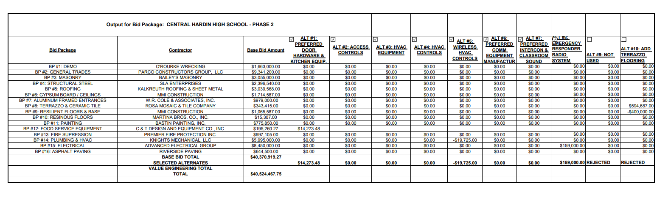
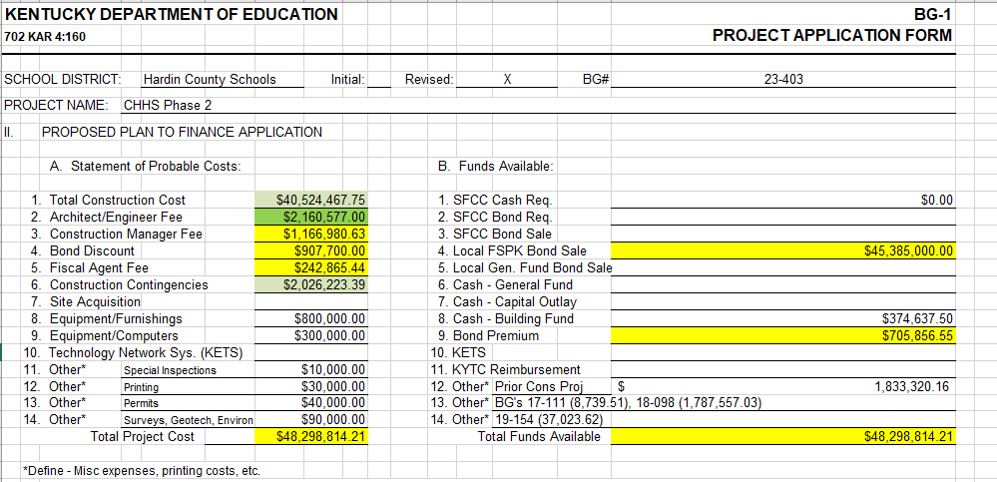

*See attached Docments

RECOMMENDATION:

I recommend that the Board award contracts for bid packages 7 and 12 to W.R. Cole (7) and C and T design (2) and accept alternates 1 and 8 for bid packages 12 & 15 giving a total construction cost for phase II of $ 40,524,467.75.

RECOMMENDED MOTION
i move that the Board award contracts for bid packages 7 and 12 to W.R. Cole (7) and C and T design (2) and accept alternates 1 and 8 for bid packages 12 & 15 giving a total construction cost for phase II of $ 40,524,467.75.

